 | 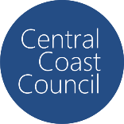
COUNCIL ASSESSMENT REPORT
HUNTER AND CENTRAL COAST REGIONAL PLANNING PANEL

PANEL REFERENCE & DA NUMBER | PPSHCC – 146 – Central Coast – DA/1750/2022
PROPOSAL | Alterations & Additions to Existing Hotel, Serviced Apartments & Golf Club plus Construction of 26-storey Mixed Use Building comprising of Serviced Apartments (97), Residential Units (98), Restaurant, Bar, Conference Centre & Additional Parking
ADDRESS | Lot 4 DP270434 & Lots 1, 2, 4, 5 and 6 DP280015 & Lot 171 DP270434  50 Parry Parade, 40 Kooindah Boulevard and 50 Kooindah Boulevard, Wyong
APPLICANT | Nigel Dickson, Dickson Rothschild
OWNER | Michael Jou & Yanjie Li
DA LODGEMENT DATE | 7 September 2022
APPLICATION TYPE | Integrated DA (Rural Fires Act 1997)  Nominated Integrated (Water Management Act 2000)
REGIONALLY SIGNIFICANT CRITERIA | Clause 2.19, Schedule 6 of State Environmental Planning Policy (Planning Systems) 2021: Development that has a capital investment value of more than $30 million
CIV | $88,556,069.00 (excluding GST)
CLAUSE 4.6 REQUESTS | N/A
KEY SEPP/LEP | - SEPP (Building Sustainability Index: BASIX) 2004  - SEPP (Transport and Infrastructure) 2021  - SEPP (Biodiversity and Conservation) 2021  - SEPP (Resilience and Hazards) 2021  - SEPP (Planning Systems) 2021  - SEPP No 65—Design Quality of Residential Apartment Development  - Central Coast Local Environmental Plan 2022  - Central Coast Development Control Plan 2022  - Draft Remediation of Land SEPP
TOTAL & UNIQUE SUBMISSIONS KEY ISSUES IN SUBMISSIONS | 106 submissions comprising 104 objections and 2 submissions in support. The key issues raised include: height, bulk and scale incompatible with the existing and desired character of the area; visual impacts; social impacts and lack of community consultation; permissibility and inconsistency with zone objectives; inconsistent with approved master plan; insufficient documentation; no Community Association approval and non-compliance with By-laws; conflict between residents and tourists; acid sulfate soils; environmental impacts; access, traffic and parking impacts; construction impacts; site contamination; inadequate sewer system; adverse impacts on residential amenity (noise, privacy, visual impacts, dust); building on a wetland cannot structurally support the building; flooding; community facilities; overshadowing; aesthetics and urban design.
DOCUMENTS SUBMITTED FOR CONSIDERATION | Council Assessment Report and Attachments A-D  - Attachment A – Draft reasons for refusal  - Attachment B – ADG compliance table  - Attachment C – DCP Compliance table  - Attachment D – Proposed architectural plans
SPECIAL INFRASTRUCTURE CONTRIBUTIONS (S7.24) | No
RECOMMENDATION | Refusal
DRAFT CONDITIONS TO APPLICANT | N/A
SCHEDULED MEETING DATE | 2 May 2023
PLAN VERSION | 27 March 2019
PREPARED BY | Jennifer Tattam
DATE OF REPORT | 24 April 2023

EXECUTIVE SUMMARY

The site is part of the Kooindah Waters Estate which is located approximately 1.5km east of Wyong town centre. The Estate covers an area of approximately 80 hectares and includes an 18-hole golf course, 252 dwelling sites, a golf club building, tourist accommodation and car parking.

The site is comprised of seven lots being Lot 4 DP270434, Lots 1, 2, 4, 5 and 6 DP280015 and Lot 171 DP270434. Lot 4 DP270434 is a vacant lot. Lots 4, 5 and 6 DP280015 contains the golf club building which includes 20 tourist suites. Lot 2 DP280015 contains tourist accommodation and Lot 1 DP280015 contains the at grade car parking area. Lot 171 DP270434 contains the golf course and system of wetlands that surround the estate.

The site is identified as bushfire prone land (Vegetation Buffer) and is subject to flooding. The site has high groundwater and acid sulfate soils (ASS). The site is also adjacent to two mapped wetlands.

The proposal is for alterations of the existing golf club building and erection of a 26-storey mixed use building to the west of the existing golf club on Lot 4 DP270434. The existing and proposed buildings are to be integrated as one building with connections via the lower ground floor car park, the upper ground floor and Level 1. The proposed 26 storey mixed-use building includes 97 serviced apartments, 98 residential units, restaurant, function rooms, two bars (includes a sky bar), gym/spa, swimming pool and meeting rooms and three levels of car parking (two basement levels).

The application was lodged on 7 September 2022 and is subject to the provisions of the Central Coast Local Environmental Plan 2022 (CCLEP 2022) and the Central Coast Development Control Plan 2022 (CCDCP 2022). The site is zoned SP3 Tourist, RE2 Private Recreation and C3 Environmental Management under the CCLEP. The proposed mixed-use development is located on land zoned SP3 Tourist, and portions of the RE2 Private Recreation and C3 Environmental Management land are proposed for construction purposes.

Tourist and visitor accommodation, food and drink premises and function centres are permitted in the SP3 Tourist zone and residential accommodation is prohibited. However, the site is subject to additional permitted uses that enable development for the purposes of residential accommodation if the consent authority is satisfied that tourist and visitor accommodation will remain the dominant use on the land as a whole. However, permissibility of the residential accommodation has not been established and it is not considered that tourist and visitor accommodation will remain the dominant use of the land as a whole, a fundamental issue which requires refusal of the application.

In 2003, approval was issued for a master plan and the subject application states that the proposal is the final stage of development of the approved master planned and substantially built resort and residential community. However, the master plan envisaged a maximum three storey high building for tourist accommodation on the subject site.

The principle planning controls relevant to the proposal include State Environmental Planning Policy No 65 – Design Quality of Residential Apartment Development (‘SEPP 65’), the Central Coast Local Environmental Plan 2022 and the Central Coast Development Control Plan 2022 (‘DCP’). The proposal is inconsistent with various provisions of the planning controls including:

- Design quality principles of SEPP 65 including Principle 1: Context and neighbourhood character, Principle 2: Built form and scale, Principle 3: Density, Principle 4: Sustainability, Principle 5: Landscape, Principle 6: Amenity, Principle 7: Safety, Principle 8: Housing Diversity and Social Interaction and Principle 9: Aesthetics.
- Provisions of the ADG including non-compliant separation distances for visual privacy (Part 3F), inappropriate vehicle access (Part 3H), car parking shortfall (Part 3J), lack of solar access (Part 4A) and natural ventilation (Part 4B), inadequate private open space (Part 4E), acoustic privacy issues (Part 4H), inadequate apartment mix (Part 4K) inadequate building facades (Part 4M), non-compliance with the mixed-use provisions (Part 4S) and waste management (Part 4W).
- The proposed residential component fails to comply with the additional permitted use provisions of CCLEP 2022.
- The proposal is inconsistent with the objectives of the SP3 Tourist zone, the RE2 Recreation zone and the C3 Environmental Management zone.
- 1200% variation to the maximum building height control in the CCDCP (Chapter 2.3 Residential flat buildings) and 285% variation to the maximum permitted floor space ratio proposed.
- Non-compliance with the car parking requirements of CCDCP Chapter 2.13 (Traffic and Parking) and Chapter 2.14 (Waste Management).
- The proposed bulk and scale of the development are not in character with either the existing or future desired character of the area, an aim of the CCLEP 2022 and objective of the CCDCP 2022.
- The proposal also fails some of the matters for consideration under Section 4.15(1) of the EP& A Act in relation to potential adverse impacts to the surrounding area including noise, overlooking, visual impacts, light spill and construction impacts.
- The site is not suitable for the development and the development is contrary to the public interest given it is inconsistent with various planning controls.

The application was placed on public exhibition with 106 submissions being received. These submissions raised issues relating to building height, bulk and scale and incompatibility with existing/desired local character, visual impacts, inconsistency with the approved master plan, traffic and parking impacts, impacts on residential amenity including potential overlooking and noise, ecological impacts and lack of suitable infrastructure. These issues are considered further in this report.

The application was referred to NSW Rural Fire Service (GTAs provided), DPIE Water (insufficient information provided by the applicant), Water NSW (GTA’s not received) and Transport for NSW (no objection and comments provided).

The jurisdictional prerequisites under CCLEP 2022 and the relevant SEPPs have not all been satisfied. The applicant has failed to satisfy Council in regard to Clause 5.21 (flood planning) of the CCLEP 2022 as well as Clause 7.6 (essential services) and Clause 4.6 of SEPP Resilience and Hazards.

The application is referred to the Hunter and Central Coast Regional Planning Panel (‘the Panel’) as the development is ‘regionally significant development’, pursuant to Section 2.19(1) and Clause (2) of Schedule 6 of State Environmental Planning Policy (Planning Systems) 2021 as the proposal has a capital investment value of more than $30 million.

The key issues associated with the proposal include:

- Permissibility - The proposed residential accommodation component of the proposal is not permissible in the SP3 zone. However, the site is subject to additional permitted uses which states that residential accommodation is permitted with development consent if the consent authority is satisfied that tourist and visitor accommodation will remain the dominant use on the land as a whole. Insufficient information has been provided to satisfy Council that the proposed development is permissible.
- Zone objectives – The objectives of the SP3 Tourist zone permits ‘limited permanent accommodation’. It is not considered that the proposal is consistent with this objective. The proposal also fails to comply with the objectives of the RE2 and C3 zones.
- Urban Design – The bulk and scale of the proposal is incompatible with both the existing and desired future character of the area. The proposal is out of context and results in a density that is not appropriate for the site. The bulk and scale of the development will result in adverse visual impacts on neighbours and the locality. There are also numerous non-compliances with requirements of the ADG which will impact the internal amenity of occupants as well as neighbours.
- Inconsistent with approved Master Plan – the master plan envisaged a maximum three storey building for tourist accommodation on the site.
- Landowner’s consent – consent of the Community Association has not been provided.
- Ecology – insufficient information has been provided to determine whether there will be impacts on threatened ecological communities, coastal wetlands and biodiversity mapped vegetation.
- Car Parking – car parking has not been adequately addressed by the proposal, and the proposed parking variation is not recommended for support.
- Vehicle access – inadequate access provided to the proposed car parking areas and potential conflict with waste collection vehicles.
- Amenity impacts – on residential neighbours from overlooking, noise, visual impacts, light spill and construction activities.
- Flooding – the application has not demonstrated that the proposal will not result in risk to life from flooding.
- Insufficient documentation – in regard to acid sulfate soils, dewatering, site contamination, geotechnical constraints, Aboriginal due diligence, noise, social impacts, economic impacts, sewer and water, construction management and waste management.

- Waste management – proposal fails to comply with the Central Coast Waste Control Guidelines with regard to the separation of residential and commercial waste.

Following a detailed assessment of the proposal, pursuant to Section 4.16(1)(b) of the EP&A Act, DA/1750/2022 is recommended for refusal subject to the reasons contained at Attachment A of this report.

On 15 March 2023 a Class 1 Application was filed in the Land and Environment Court of NSW. The application is an appeal against the respondent’s deemed refusal of the development application.

- THE SITE AND LOCALITY

  - The Site

The site is located in the established suburb of Wyong, within the existing golf course resort and residential estate known as Kooindah Waters. The site comprises seven lots as follows:

- Lot 4 DP270434 (50 Parry Parade)
- Lots 1, 2, 4, 5 and 6 DP280015 (40 Kooindah Boulevard)
- Lot 171 DP270434 (50 Kooindah Boulevard)

Figure 1 below shows the location of Lot 4 DP270434 and Lots 1, 2, 4, 5 and 6 DP280015.

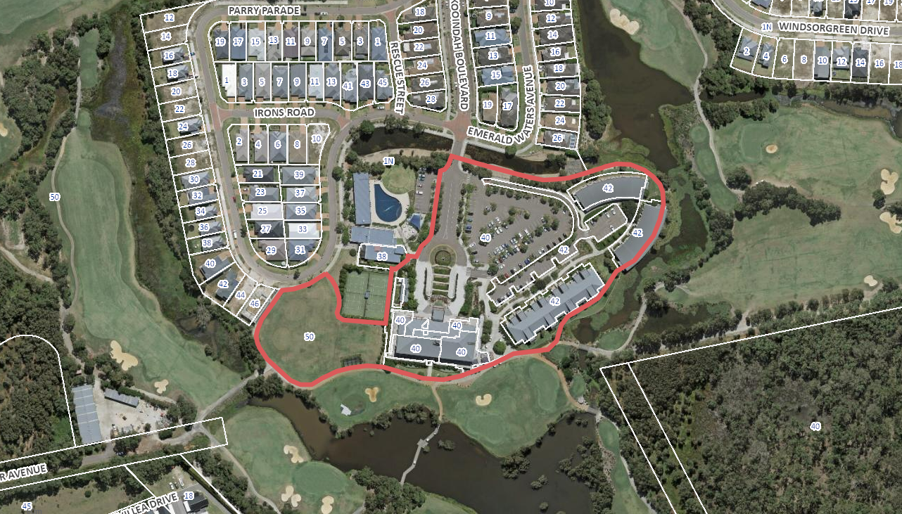
Figure 1: Aerial photo of 50 Parry Parade and 40 Kooindah Boulevard
Figure 2 below shows the location of Lot 171 DP270434 – a portion of which is proposed to be used for construction access and construction management purposes.

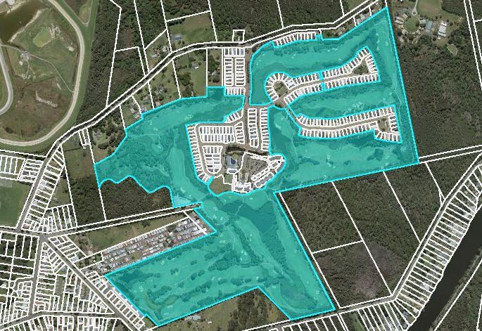
Figure 2: Aerial photo of 50 Kooindah Boulevard
All of the lots that make up the site are part of community scheme DP270434 with DP280015 being a subsidiary scheme within the community scheme. The roads that make up the estate are community property along with a central area that contains the recreation services for the estate (swimming pool and tennis courts).

The site is irregular in shape and has an overall area of 61.7153 Ha. Details of the various lots are as follows:

Lot 4 DP270434 (50 Parry Parade)

This lot has an area of 4,831m², width of 96.6m and length of 83.1m. It has 35m of road frontage to Parry Parade to the north. It is vacant, apart from a small practice net, is covered in lawn and has a relatively flat topography. It is located on the western side of the existing golf club building.

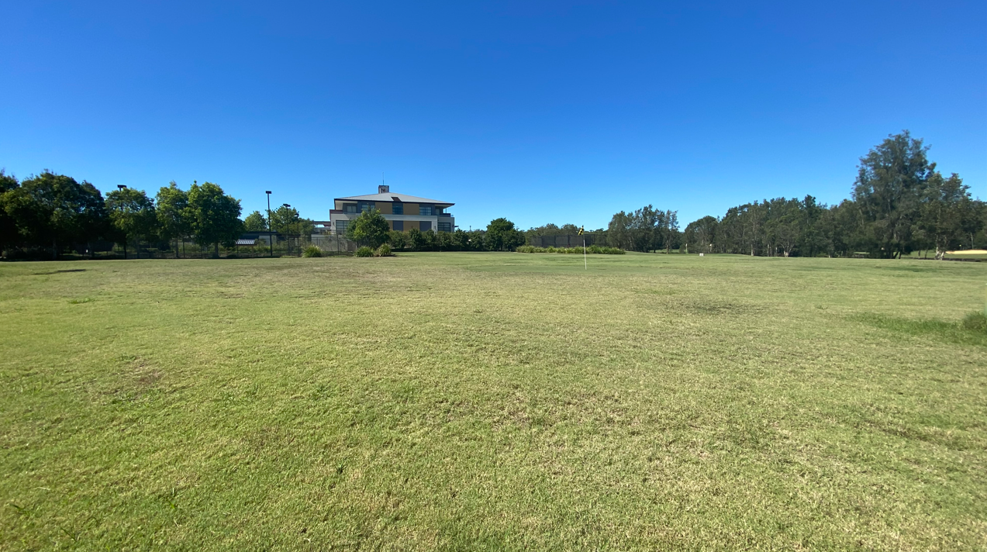
Figure 3: Photo of Lot 4 DP270434
Lots 1, 2, 4, 5 and 6 DP280015 (40 Kooindah Boulevard)

The combined area of these lots is 22,322m². The lots have been developed with the golf club building and serviced apartments as follows:

- Lots 4, 5 and 6 DP280015 is occupied by a three-storey building used as the Kooindah Waters Golf Club and Hotel which includes 20 hotel suites;
- Lot 2 DP 280015 contains 64 townhouse and serviced apartment buildings (Buildings 2A, 2B and 1C);
- Lot 1 DP 280015 contains the central at grade car park.

There are some amenities buildings (e.g., the swimming pool) on Lot 3 DP 280015 to the west of the site. This lot has not been included in the development site as no works are proposed to these buildings, their use is shared with adjoining residential lots, and they are owned by the Community Association.

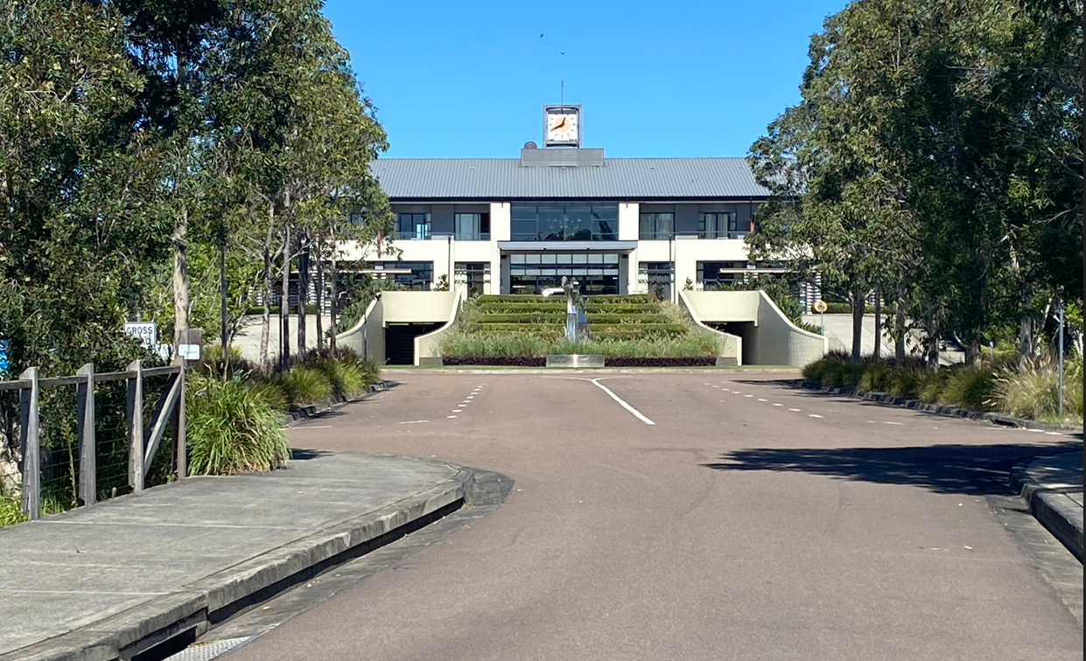
Figure 4: Photo of existing Golf Club building
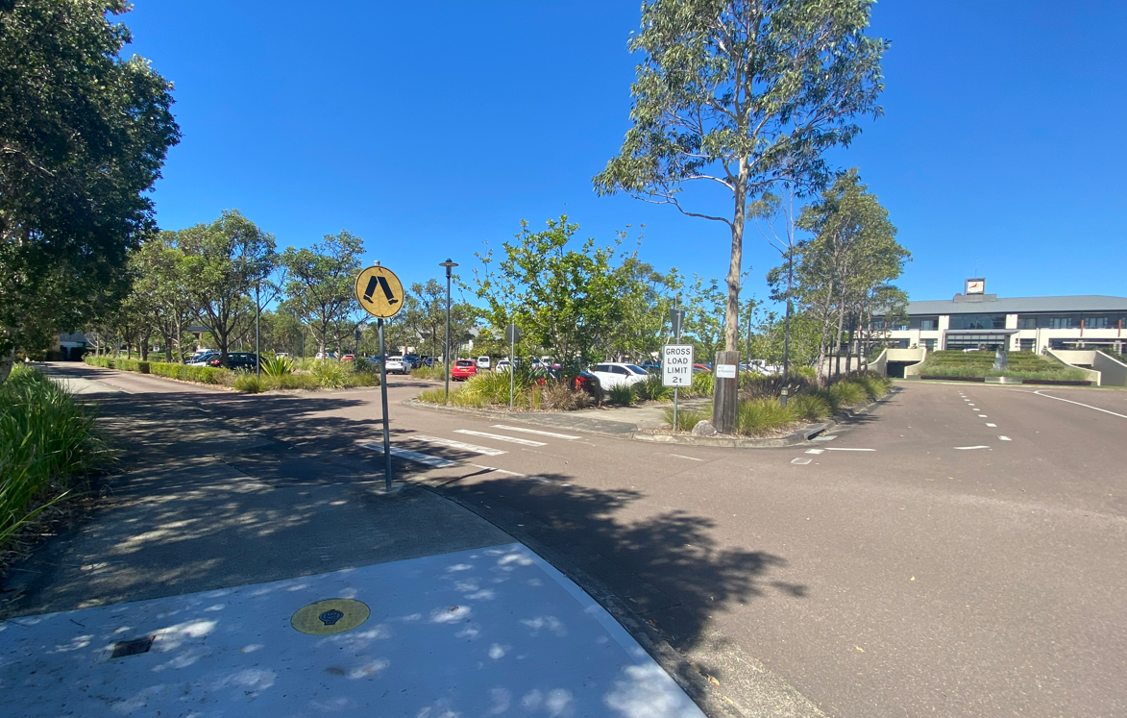
Figure 5: Photo of existing Gold Club and at grade car parking area
Lot 171 DP270434 (50 Kooindah Boulevard)

This is a large irregularly shaped lot that contains the golf course and a system of wetlands in the Kooindah Waters Estate. This lot has an overall area of approximately 59 hectares. A small portion to the west of the other lots within the site, is proposed to be used for construction purposes.

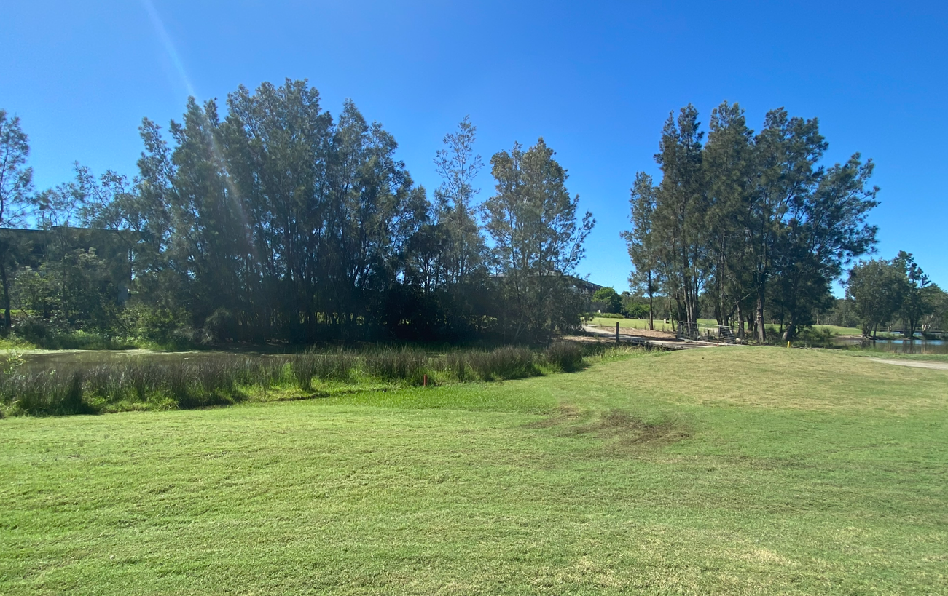
Figure 6: Photo of portion of Lot 171 DP270434 to be used for construction purposes

The Kooindah Waters Estate covers a total area of approximately 80 hectares. The Estate is bound by Pollock Avenue to the north, Warner Avenue to the west and McDonagh Road to the south. The Estate includes:

- 252 residential lots;
- 18-hole golf course plus pro shop;
- three storey 20 suite hotel resort/golf club with restaurant, bar, lounge, function rooms;
- three storey building containing 44 serviced apartments (Building 1C);
- two x two storey buildings containing 10 serviced apartments in each (buildings 2A & 2B) (total of 84 rooms for tourists);
- recreational facilities including spa, gym, swimming pool, tennis courts;
- 213 car parking spaces including 23 spaces in the clubhouse basement, 44 dedicated spaces for guests of the townhouse and apartment accommodation, 13 spaces adjacent to the recreational/health facility and 133 general spaces on an at-grade car park;
- landscaping and an extensive network of wetlands which provide amenity, biodiversity and stormwater treatment functions. These wetlands are integrated into the golf course and form the central basis of the stormwater management system. They also provide natural wetland habits for native flora and fauna.

The site has a relatively flat topography. The site has high groundwater, acid sulfate soils and is subject to flooding. Portions of the site in the south-east and west are identified as bushfire prone land (Vegetation buffer).

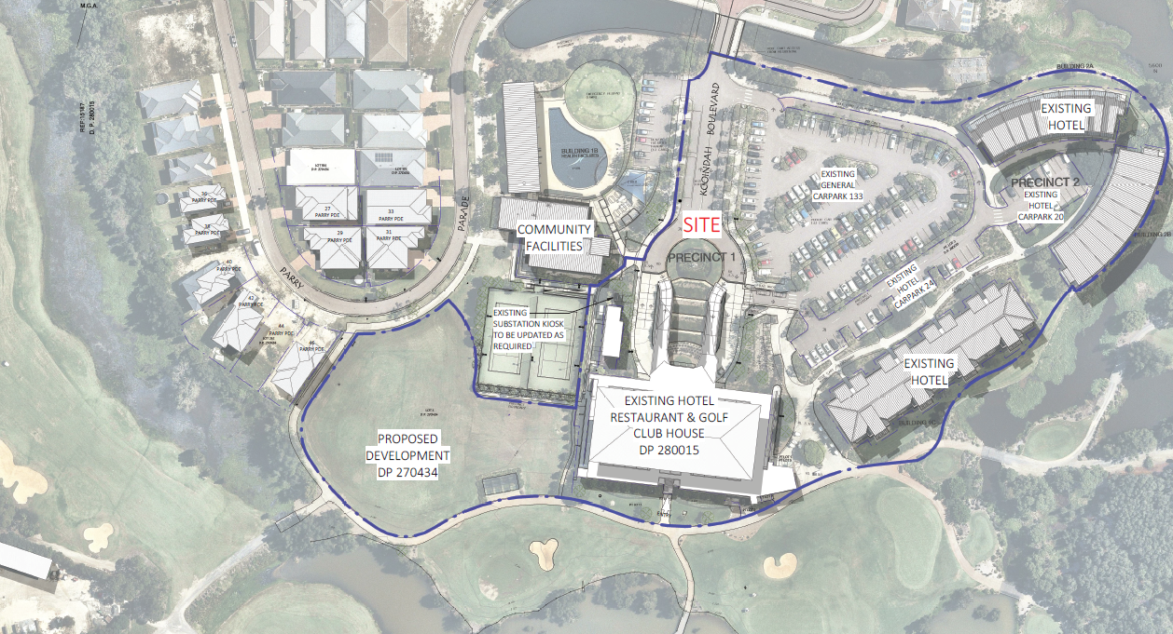
Figure 7: Aerial view of the site showing various land uses
  - The Locality

The site is approximately 1.3km east of the Wyong town centre and rail station in a direct line and approximately 1.5km via the most direct walking route (via Warner Avenue). It is to the south-east of the Wyong Racecourse and Showground, north of the Wyong River and west of Tuggerah Lake.

The site is located within the Kooindah Waters Estate. Adjoining the site to the north and north-east are low density residential dwelling houses that are part of the Kooindah Waters Estate. The golf course is located to the south and further south (past the golf course) there is a mobile home park on Boyce Avenue and then a mix of rural/residential developments towards the Wyong River. North of the estate are rural residential properties.

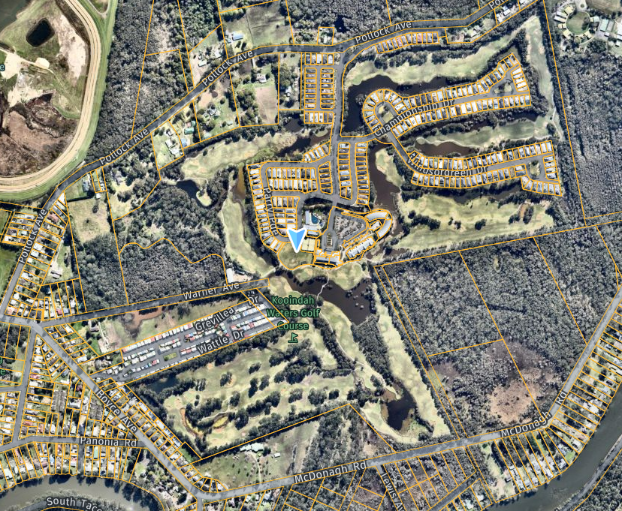
Figure 8: Broader aerial view of the site and surrounds
The site is relatively remote from services and public transport. The Wyong train station is located approximately 1.3km to the west. A public bus stop is located north of the site on Pollock Avenue providing access to the Route 81 bus service running between Pollock Avenue and the train station. Additional bus stops are located on the Pacific Highway (approximately 1.5km walking distance from the site) which provides access to services on the Central Coast.

The area is primarily characterised by detached housing in a landscaped setting – refer to images below of dwellings opposite Lot 4 DP270434 and within the Kooindah Waters Estate generally.

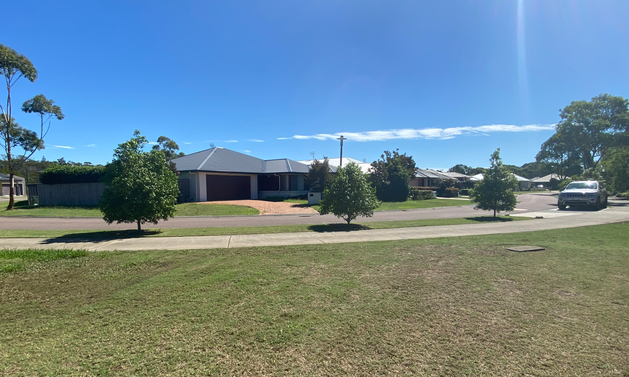
Figure 9: Existing dwellings opposite the proposed tower in Parry Parade
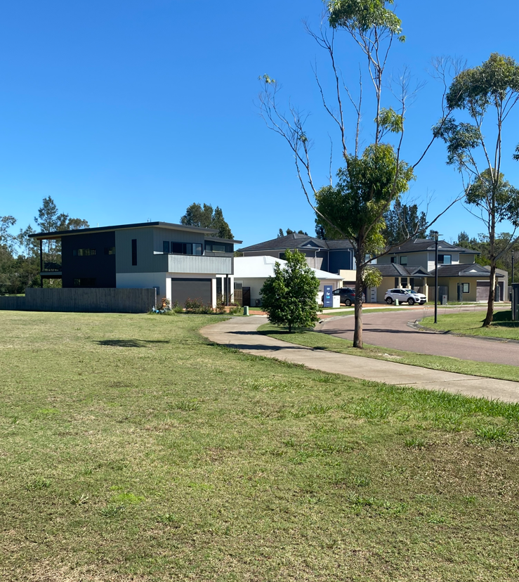
Figure 10: Existing dwellings located west of the proposed tower
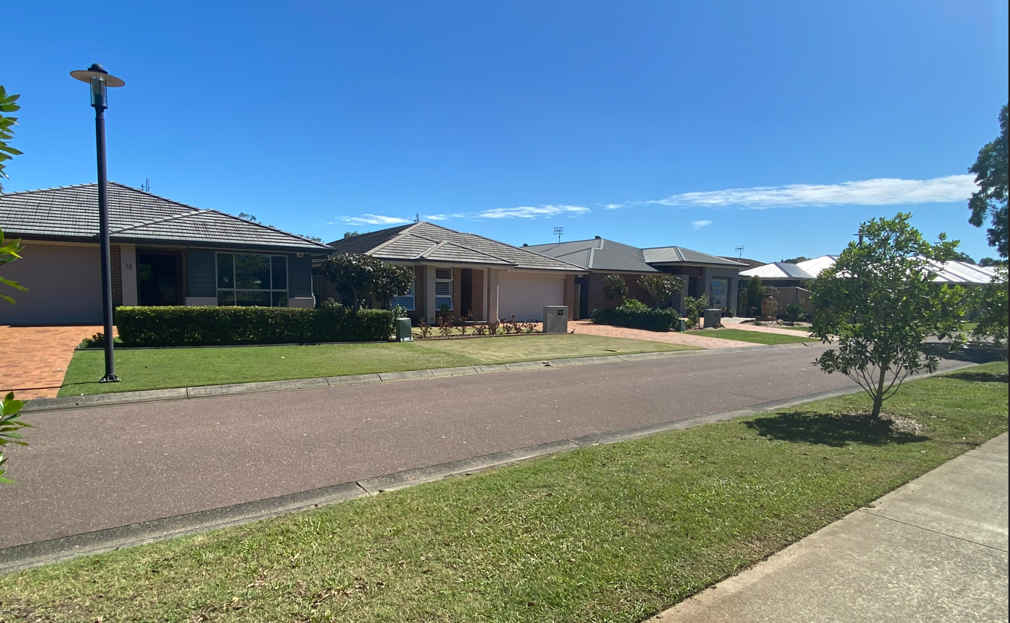
Figure 11: Typical dwellings within Kooindah Waters Estate
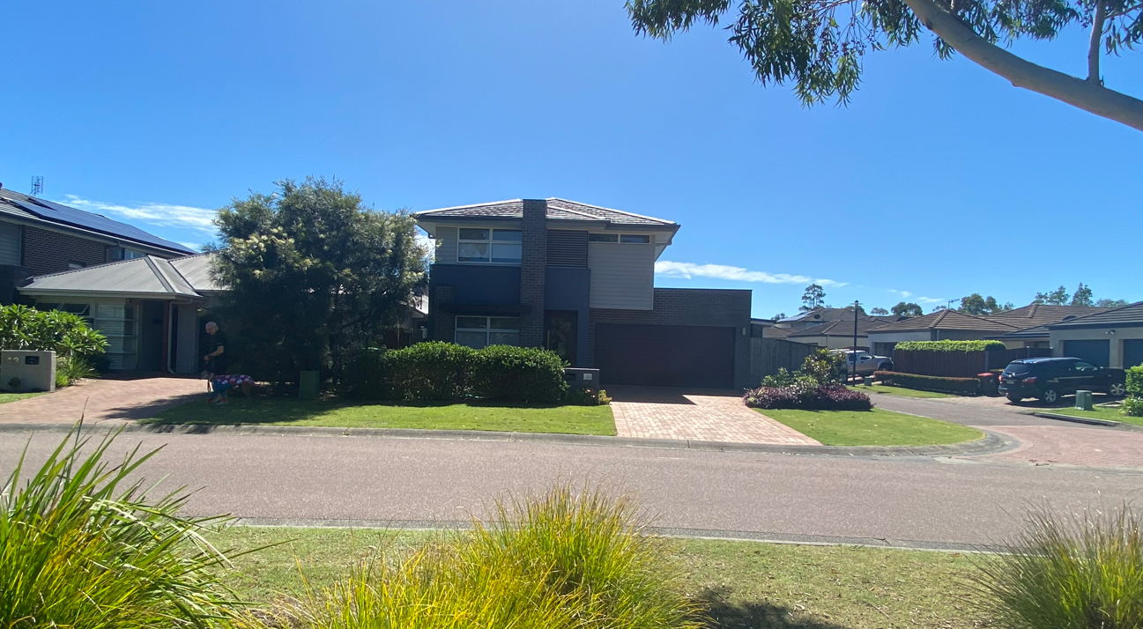
Figure 12: Typical dwellings within Kooindah Waters Estate

- THE PROPOSAL AND BACKGROUND

  - The Proposal

Development consent is sought for alterations of the existing golf club building and erection of a 26-storey mixed use building to the west of the existing golf club. The existing and proposed buildings are to be integrated as one building with connections via the lower ground level car park, the upper ground floor and level 1.
The proposed works include the following:
- Alterations and additions to the existing golf club building comprising alteration of ground floor commercial spaces to provide for a dedicated golf club (286m²), new foyer and kitchen area and restaurant (239m²). The western side of the building is also to be integrated into the new building to allow for access to the new building via the lower ground floor car park, the upper ground floor and level 1.

- The new 26 storey building adjoining the existing golf club building is to comprise:
  - Two new levels of basement parking (total of 155 car parking spaces)
  - Lower ground parking level (98 car parking spaces, 33 bicycle spaces and 5 motorbike spaces) and five tourist suites that face Parry Parade. This level of the car park connects with the existing car parking area of the golf club building to the east.
  - Upper ground includes second storey of the five tourist suites, function rooms, kitchen, restaurant, bar and back of house facilities.
  - Level 1 – meeting rooms, gym/spa, swimming pool, change rooms and amenities, and 12 tourist suites.
  - Levels 2 to 5 – 92 serviced apartments.
  - Levels 6 to 22 – 98 residential apartments.
  - Level 23 – roof top sky bar, function space, amenities and back of house.
  - Level 24 – plant and equipment including photovoltaic arrays.

- An additional 253 on-site car parking spaces are proposed, taking total on-site parking to 453 spaces.

- All vehicle access and egress are proposed via the existing commercial driveway off Kooindah Boulevard (not Parry Parade) and through the existing golf club building.

- The proposal includes the removal of trees/vegetation for construction management purposes, landscaping and the provision of services.

- Construction access is proposed from Warner Avenue south-west of the proposed tower. A construction materials handling/drop off zone is proposed between the end of Warner Avenue and the proposed tower building.

- New pedestrian and bicycle access off Warner Avenue.
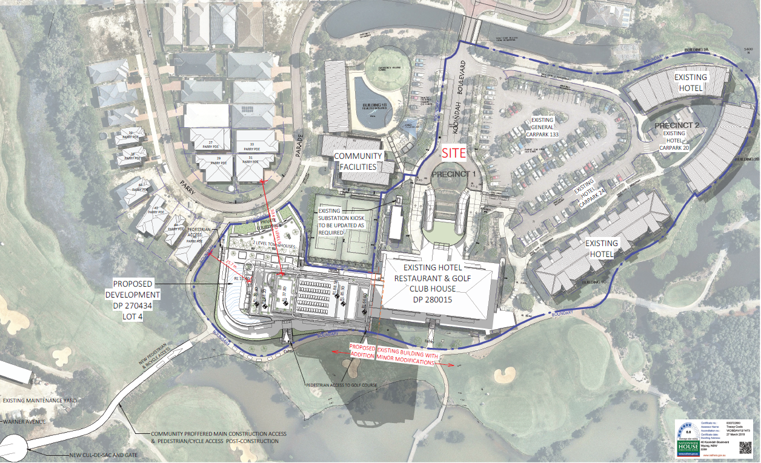
Figure 13: Proposed Site Plan showing Lot 4 DP 270434 & Lots 1, 2, 4, 5 and 6 DP280015
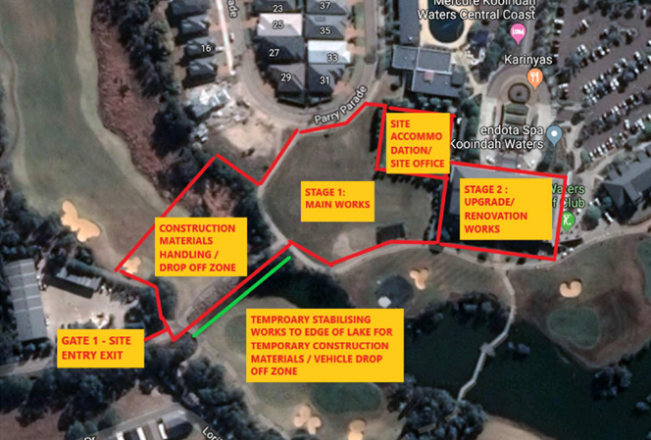
Figure 14: Excerpt from Construction Management Plan showing location of materials handling areas/drop off zone and access in relation to the main tower site and golf club building

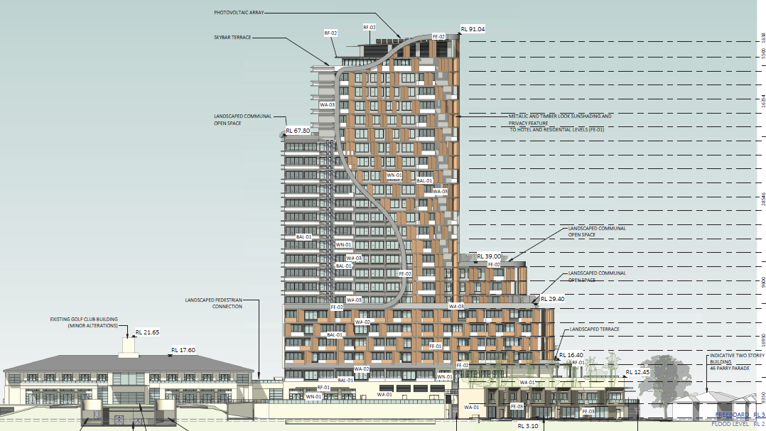
Figure 15: North elevation of proposed tower building
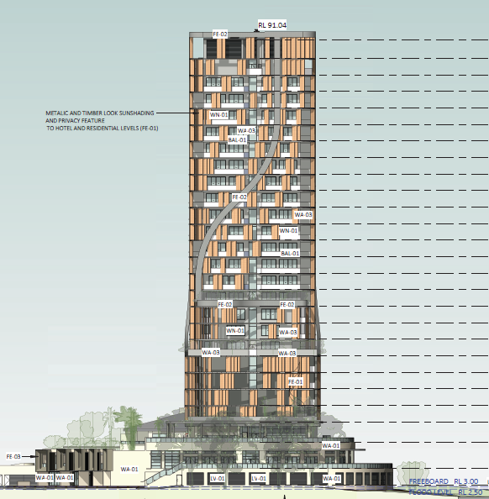
Figure 16: West elevation of proposed tower building
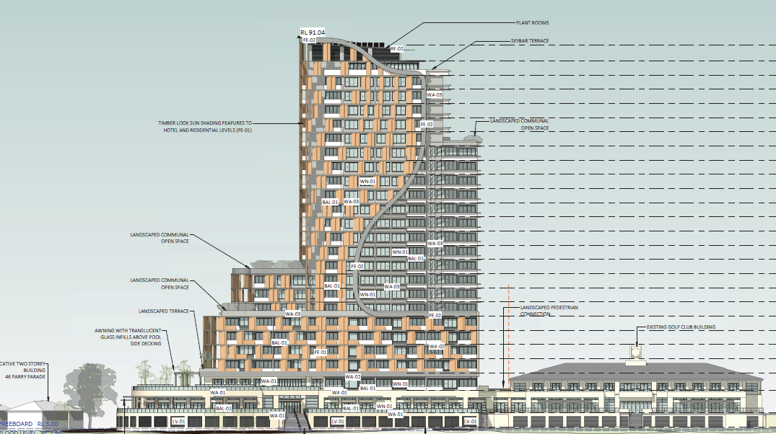
Figure 17: Southern elevation of proposed tower building
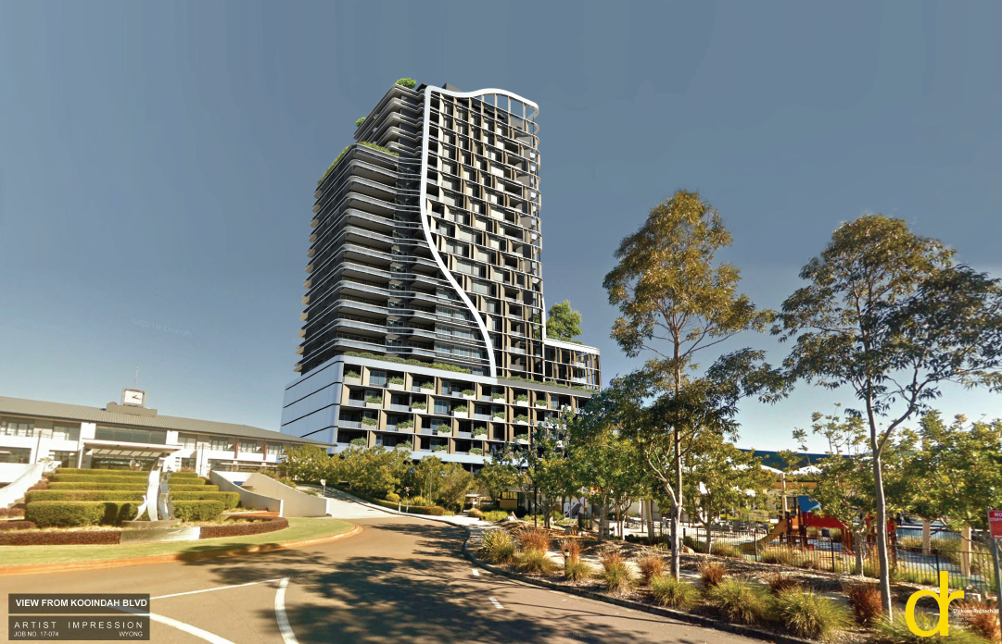
Figure 18: Artist's impression of the proposed tower building

Table 1 below contains the development data relevant to Lot 4 DP 270434 which is proposed to be developed with the 26-storey mixed-use tower.
Table 1: Development Data
Control | Proposal
Site area | 4,831m²
GFA | 3,301m² - proposed commercial  5,850m² - proposed serviced apartments  11,173m² - proposed residential units
FSR (retail/residential) | 4.21:1
Clause 4.6 Requests | No
No of residential apartments | 98
No of tourist apartments | 97
Max Height | 87.938m
Landscaped area | 444m² (9%) – deep soil landscaped area
Car Parking spaces | An additional 253 on-site car parking spaces are proposed, taking total on-site parking to 463 spaces.
Setbacks | Front setback (Parry Parade): 6m  Rear setback (golf course): 1.5m  Side setback (west): 3.190m  Side setback (east): Nil (the tower will be joined to the existing golf club building)
Communal open space | 1,208m² (25%)

  - Background

Two pre-lodgement meetings were held prior to the lodgement of the application on 2 May 2018 (PL/76/2018) and 6 December 2018 (PL/313/2018).

Various issues were raised at the meetings and in the minutes including: permissibility and the fact that tourist and visitor accommodation must remain the dominant use on the site in accordance with the SP3 zone objectives and Schedule 1 of the LEP; impacts on neighbour amenity; visual impacts; compliance with SEPP 65 – Design Quality of Residential Apartment Development, the Apartment Design Guide and the DCP; proposed variation to the car parking requirements is too great and unlikely to be supported; the need to identify the current patronage/level of usage of the golf course that generates the need for the additional tourist and residential accommodation; suitability of the site for the development; Aboriginal due diligence; acid sulfate soils; waste; flooding; servicing and the requirement for public art.

It is noted that a number of issues raised in pre-lodgement meetings have not been adequately addressed by the development application as lodged.

Upon formal lodgement of the application on 7 September 2022 Council completed a comprehensive assessment. Significant issues were raised, and on 20 December 2022 Council issued a letter to the applicant requesting that the development application be withdrawn.

A chronology of the development application since lodgement is outlined below including the Panel’s involvement (briefings etc) with the application:

Table 2: Chronology of the DA
Date | Event
7 September 2022 | DA lodged
16 September 2022 | DA referred to external agencies
23 September 2022 | Exhibition of the application
9 November 2022 | Kick off Briefing
18 November 2022 | The application was re-notified to clarify that the proposal includes a 26-Storey Mixed Use Building, and that construction access is proposed via Warner Avenue, Wyong.
20 December 2022 | Letter to applicant outlining the issues raised by the proposal and requesting that they withdraw the application
21 February 2023 | Panel briefing

  - Site History

Up until 1986, the area was mainly used for non-commercial grazing purposes. It contained an abandoned airfield and a dumping area for disused chemical storage drums north of Warner Avenue. In 1985 a major fire occurred within the bunded drum dump area.

In December 1986, Council granted consent to a nine-hole golf course and riding school. The golf course was subsequently amended to 13 holes shortly after.

In 1987 the NSW State Pollution Control Commission issued a notice to the then owner under Section 35 of the Environmentally Hazardous Chemicals Act 1985, declaring the drum dump area a “designated contaminated site”. A notice required the landowner to bury the burnt-out drums within the bunded area, remove affected topsoil and bury it with the drums, and place at least one metre of clean compacted soil over the top of the buried drums. This notice was not complied with until 1993 when the work was undertaken by new owners.

Approval to develop an 18 hole golf course, club house and ancillary facilities was granted by Wyong Council in March 1993 (DA No 762/90). As the proposal involved the extension of the golf course into Wetland Area 899 (identified under SEPP No. 14) the concurrence of the Director of Planning was required, and this concurrence was granted in June 1992.

In November 1994, an enabling clause was inserted into Wyong Local Environmental Plan 1991 (LEP No 125) allowing the construction of a Managed Resort Facility except that area affected by the drum dump contamination. The LEP allowed for up to 75% of the accommodation on the site to be permanent.

Council subsequently granted consent in April 1996 for a Managed Resort Facility on the site (DA/180/95) and a community title subdivision (DA/179/95) of the development. The managed resort facility incorporated an eight-storey hotel, childcare centre, chapel and 252 dwellings.

Master Plan

In October 2002, an application was lodged for a masterplan or staged development application for a proposed managed resort facility and golf course. The intention was that more detailed development applications relating to the proposed residential and hotel components of the development would be the subject of subsequent stages.

On 18 June 2003 DA/2732/2002 for ‘Master Plan for a Managed Resort Facility, including 150 room hotel, 252 residential dwellings, 18-hole golf course, golf club, recreation facilities and associated car parking and site works was approved by Council. It included the following components:

- 18-hole golf course
- 3 storey resort building (the existing Golf Club building)
- Two 3 storey buildings, one either side of the Golf Club, containing150 hotel rooms
- Health club, tennis courts and swimming pool
- 252 two storey dwellings on individual community title allotments; and
- Associated landscaping, car parking and bulk earthwork for construction of the golf course
This approval provided for a more sensitive development including a two to three storey hotel instead of the previously approved eight storey hotel. Development consents relating to DA/180/95 and DA/179/95 were surrendered to Council prior to the issue of a Construction Certificate for the managed resort facility.
Various development consents have been issued over the past decade to address minor modifications to the original development consent (flood levels and pavement reconstruction) and to gain approval for the community title subdivision and residential and resort components of the development.
The approved masterplan is shown below (Figure 8).
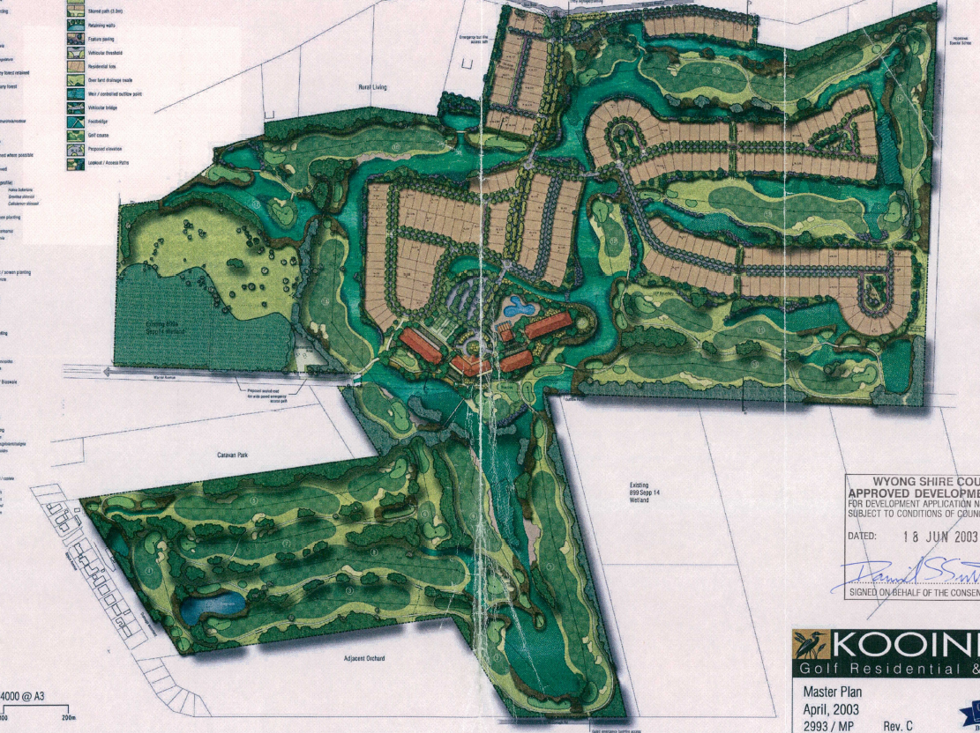
Figure 19: Approved Masterplan DA/2732/2022
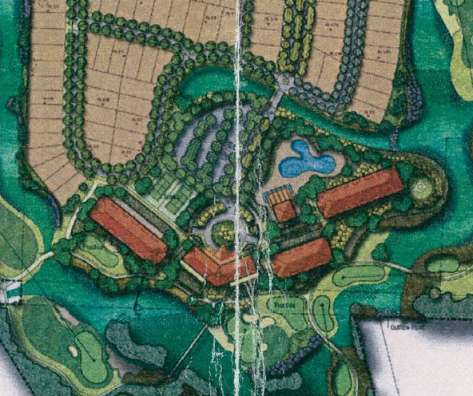
Figure 20: Excerpt from the approved Masterplan
Since the masterplan, there have been various development consents granted in relation to the site including the following relevant approvals:

- Development Consent DA/3087/2004 – proposed 107 room resort Club House, Health & Leisure Facilities parking & landscaping granted 10 June 2005. This DA was commenced, and development has occurred.

- Development Consent DA/1092/2011 was granted for a golf driving range (recreation facility) on 14 June 2012. This consent was not commenced and has since lapsed.

- Development Consent DA/914/2013 for concept approval for resort accommodation concept plan (Stage 1) including conversion of existing resort accommodation to residential apartments - Kooindah Waters on Lot 4 at 50 Parry Parade. This consent lapsed 19 February 2017.

- DA/914/2013 was approved on 19 Feb 2013 for a concept plan (Stage 1 on Lot 4) including conversion of existing resort accommodation to residential apartments. This consent was not commenced and has since lapsed.

The Statement of Environmental Effects submitted with the application states that the development is the ‘final stage of development of an approved master planned and substantially built resort and residential community. The initial consent (DA/2732/2022 approved in 203) is known as the 2002 Master Plan. The Master Plan has been implemented in subsequent DAs. As such the development is taking place on land approved and designated for its purpose – a mixed use building’.

Lot 4 DP270434 is identified in the master plan for development of a maximum three storey building for the purposes of hotel rooms. It is unclear how the proponent has arrived at a mixed-use building with 26 storeys. A rationale for the development has not been provided including justification for the amount of residential and tourist units. The proposal is not consistent with the master plan (reason for refusal 5).

ENVIRONMENTAL PLANNING AND ASSESSMENT ACT 1979

Section 1.7 Application of Part 7 of Biodiversity Conservation Act 2016

This Act has effect subject to the provisions of Part 7 of the Biodiversity Conservation Act 2016 (BC Act) and Part 7A of the Fisheries Management Act 1994 that relate to the operation of this Act in connection with the terrestrial and aquatic environment.

NSW Biodiversity Conservation Act 2016
Part 7 of the BC Act relates to biodiversity assessment and approvals under the EP&A Act where it contains additional requirements with respect to assessments and approvals under this Act.
The applicant has not demonstrated that the proposal does not exceed the biodiversity offsets scheme (‘BOS’) threshold for the purposes of section 7.2 of the Biodiversity Conservation Regulation 2017, and therefore the development application may be required to be accompanied by a Biodiversity Development Assessment Report (‘BDAR’).
The development may result in clearing of areas which are mapped on the NSW Biodiversity Values Map and there is inadequate information to determine if the area of native vegetation to be cleared requires preparation of a BDAR (reason for refusal number 7).

- STATUTORY CONSIDERATIONS

When determining a development application, the consent authority must take into consideration the matters outlined in Section 4.15(1) of the Environmental Planning and Assessment Act 1979 (‘EP&A Act’). These matters as are of relevance to the development application include the following:

- the provisions of any environmental planning instrument, proposed instrument, development control plan, planning agreement and the regulations
(i) any environmental planning instrument, and
(ii) any proposed instrument that is or has been the subject of public consultation under this Act and that has been notified to the consent authority (unless the Planning Secretary has notified the consent authority that the making of the proposed instrument has been deferred indefinitely or has not been approved), and
(iii) any development control plan, and
(iiia) any planning agreement that has been entered into under section 7.4, or any draft planning agreement that a developer has offered to enter into under section 7.4, and
(iv) the regulations (to the extent that they prescribe matters for the purposes of this paragraph),
that apply to the land to which the development application relates,
- the likely impacts of that development, including environmental impacts on both the natural and built environments, and social and economic impacts in the locality,
- the suitability of the site for the development,
- any submissions made in accordance with this Act or the regulations,
- the public interest.

These matters are further considered below.

It is noted that the proposal is considered to be (which are considered further in this report):

- Integrated Development (s4.46) under the Rural Fires Act 1997
- Nominated Integrated Development (s4.46) under the Water Management Act 2000.
- Requiring concurrence/referral (s4.13) under SEPP (Transport & Infrastructure) 2021

  - Environmental Planning Instruments, proposed instrument, development control plan, planning agreement and the regulations

The relevant environmental planning instruments, proposed instruments, development control plans, planning agreements and the matters for consideration under the Regulation are considered below.

- Section 4.15(1)(a)(i) - Provisions of Environmental Planning Instruments

The following Environmental Planning Instruments are relevant to this application:

- State Environmental Planning Policy (Biodiversity and Conservation) 2021
- State Environmental Planning Policy (Building Sustainability Index: BASIX) 2004
- State Environmental Planning Policy No 65—Design Quality of Residential Apartment Development
- State Environmental Planning Policy (Planning Systems) 2021
- State Environmental Planning Policy (Resilience and Hazards) 2021
- State Environmental Planning Policy (Transport and Infrastructure) 2021
- Central Coast Local Environmental Plan 2022
- Draft Remediation of Land SEPP

A summary of the key matters for consideration arising from these State Environmental Planning Policies are outlined in Table 3 and considered in more detail below.

Table 3: Summary of Applicable Environmental Planning Instruments
(Preconditions in bold
EPI | Matters for Consideration  (Brief summary) | Comply (Y/N)
State Environmental Planning Policy (Biodiversity & Conservation) 2021 | Chapter 4: Koala Habitat Protection 2021  The site includes an area greater than 1 hectare that does not have an approved koala plan of management. An assessment of potential impacts on koala’s or koala habitat has not been provided with the application. | N
BASIX SEPP | No issues identified subject to imposition of conditions on any consent granted. | Y
SEPP 65 | Clause 30(2) - Design Quality Principles - The proposal is contrary to the design quality principles and the proposal is contrary to the ADG requirements for apartment building types, local character and context, precincts, building depth, visual privacy, carparking, solar access, natural ventilation, private open space, storage, apartment mix, facades, mixed use requirements, energy efficiency and waste management. | N
State Environmental Planning Policy (Planning Systems) 2021 | Chapter 2: State and Regional Development  Section 2.19(1) declares the proposal regionally significant development pursuant to Clause 2 of Schedule 6 as it comprises development that has a capital investment value of more than $30 million | Y
SEPP (Resilience & Hazards) | Chapter 2: Coastal Management  Works associated with the construction phase of the project are proposed within the coastal wetland proximity area and potentially the coastal wetland area. Insufficient information has been provided to confirm and no arborist or ecological assessment has been provided.  Chapter 4: Remediation of Land  Section 4.6 – Potential contamination and remediation has been considered in the assessment of the proposal. The site has had a historical use for contaminating activities and the application has failed to provide sufficient information to confirm that the site is not contaminated or is satisfactory in its contaminated state. | N  N
State Environmental Planning Policy (Transport and Infrastructure) 2021 | Chapter 2: Infrastructure  Section 2.121(4) – Traffic-generating development – the proposal constitutes a traffic-generating development as it includes more than 200 car parking spaces and therefore the provisions of Clause 2.122 of the SEPP apply. The proposal was referred to TfNSW and comments were received | Y
CCLEP 2022 | Clause 2.3 – Permissibility and zone objectives  Clause 2.5 – Additional permitted uses  Clause 5.21 – Flood planning  Clause 7.1 – Acid sulfate soils  Clause 7.6 – Essential services | N
CCDCP 2022 | Chapter 2.3 - Residential Flat Buildings  Chapter 2.13 - Transport and Parking  Chapter 2.14 - Site Waste Management  Chapter 3.1 - Floodplain Management | N
Draft EPIs | Draft SEPP (Remediation) 2018 | N

Consideration of the relevant SEPPs is outlined below.

State Environmental Planning Policy (Biodiversity and Conservation) 2021

This SEPP contains the provisions formerly contained within SEPP (Koala Habitat Protection) 2021. Prior to the granting of development consent under State Environmental Planning Policy (Biodiversity & Conservation) 2021, the consent authority must first assess whether the development is likely to have any impact on koalas or koala habitat.

Section 4.9 (development assessment process – no approved koala plan of management for land) is relevant as the land does not have an approved koala plan of management applying to the land and has an area greater than 1 hectare.

The Construction Management Plan states that vegetation will be removed adjacent to the proposed tower site for construction purposes and either side of Warner Avenue for construction access. An arborist report detailing the trees and vegetation to be removed has not been provided with the application, nor has an ecological report that includes an assessment of potential impacts on koalas and koala habitat (reason for refusal 9).

State Environmental Planning Policy (Building Sustainability Index: BASIX) 2004

State Environmental Planning Policy (Building Sustainability Index: BASIX) 2004 applies to the proposal. The objectives of this Policy are to ensure that the performance of the development satisfies the requirements to achieve water and thermal comfort standards that will promote a more sustainable development.

The application is accompanied by BASIX Certificate No.1004536M_02 prepared by Efficient Living Pty Ltd dated 19 July 2022 committing to environmentally sustainable measures. The Certificate demonstrates the proposed development satisfies the relevant water, thermal and energy commitments as required by the BASIX SEPP. The proposal is consistent with the BASIX SEPP subject to the recommended conditions of consent.

State Environmental Planning Policy No 65—Design Quality of Residential Apartment Development

This Policy aims to improve the design quality of residential flat development. The proposal has been assessed against the following matters relevant to SEPP 65 consideration:

- The 9 SEPP 65 Design Quality Principles; and
- The Apartment Design Guide (ADG)

Please note that the proposal includes 97 serviced apartments and 98 residential units. The Central Coast Local Environmental Plan 2022 defines serviced apartments as follows:

serviced apartment means a building (or part of a building) providing self-contained accommodation to tourists or visitors on a commercial basis and that is regularly serviced or cleaned by the owner or manager of the building or part of the building or the owner’s or manager’s agents.

As the proposed plans indicate that several of the serviced apartments are not self-contained, they are considered to be hotel suites instead. Therefore, the proposal includes a mix of serviced apartments (51), hotel suites (46) and residential units (98).

Clause 1.9 of CCLEP 2022 states that SEPP 65 applies to development for the purposes of serviced apartments.

Therefore, for the purposes of the assessment consideration against the 9 design quality principles relates to the whole building, whereas assessment against the ADG is restricted to the serviced apartments and residential unit components of the proposal. It is noted that the applicant’s assessment against the ADG relates to the residential units only.

Design Quality Principles

Part 4 of the Policy introduces 9 design quality principles. These principles do not generate design solutions but provide a guide to achieving good design and the means of evaluating the merits of proposed solutions. A response to those design principles, prepared by the project architect, supports the application as required by the Environmental Planning and Assessment Regulation.

The following table provides an assessment of the proposal against those principles having regard to the comments of Council’s Urban Designer:

Principle | Comment
Context and neighbourhood  character | The proposed development is within an existing golf course resort and residential estate. The estate currently has 252 residential lots, with the vast majority now occupied by dwellings of 1 and 2 storeys. The existing hotel has 20 hotel suites, 44 x serviced apartments of various sizes, and 20 town houses. The total number of townhouses, serviced apartments and suites in the existing hotel is 84. The hotel buildings range from 2-3-storeys in height.  The site is located 1.3km directly east of the Wyong railway station. The site is surrounded by the fairways of the golf course, the hotel, and some residential lots. There are natural and constructed waterways and natural and planted vegetation. The site is not within a town or village centre. Outside of the estate, there are low scale vegetated semi-rural acreages with dwellings and large areas of natural vegetation and wetlands. Residential development in the local area is 1-2 storeys set on large blocks with generous setbacks.  The proposed development of a large 26 storey tower does not relate to the existing or desired future context and neighbourhood character of the local area. The drone image on the following page shows the site looking towards the Wyong racecourse.  The predominant character is of low-rise buildings set within waterways, green fields, trees and vegetation. The site is not within a city, town or even a village. The site is within a unique community with private roads, landscaping, and shared facilities. There is a sense of belonging and shared ownership that is special about the estate. A large 26 storey tower would be out of context and character in this estate.  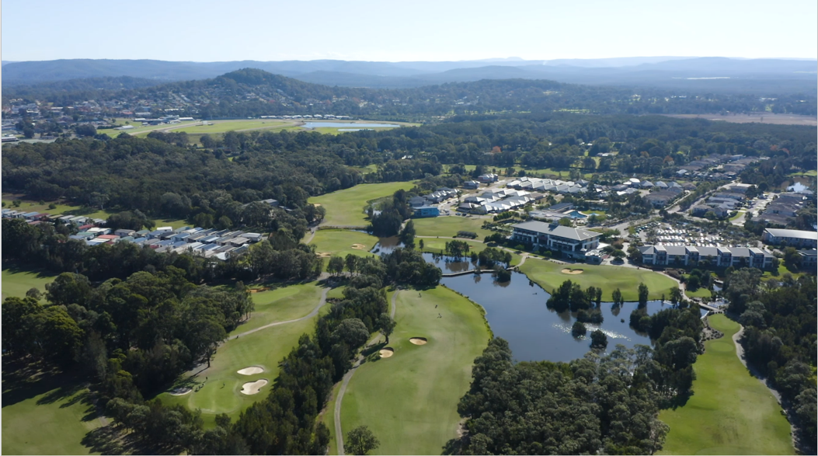  Drone image of site looking towards Wyong racecourse  The proposed south elevation has been placed on the drone image below to provide an indicative scale of development. The tower seems to be a foreign object in this setting. There is little transition between 2-3 storey development and the big jump up to 26 storeys. The estate and surroundings would appear to be overlooked and overshadowed by this development.  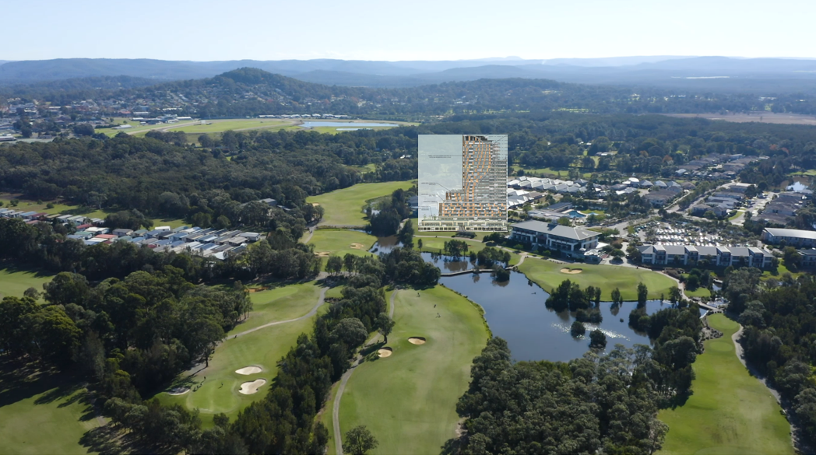  Drone image with south elevation superimposed to show indicative scale of development  In addition to not being in keeping with the context and neighbourhood character of the local area, the development is not in keeping with the context and character of the whole Central Coast region. The closest town to the development site, Wyong has its tallest buildings at only 5 storeys. The Entrance town centre and Gosford city centre both have their tallest buildings at 15 storeys.
Built form and scale | The proposed development is 26 storeys in height (not 24 as stated in the SEE) and the overall building height is 87.938m to the roof top (not 86.5m as stated in the SEE). The confusion may be that the floor plans have been labelled as upper and lower ground floor when they are both above ground, and there is a plant room that takes up a whole level on the top storey for which a floor plan has not been provided.  The built form and scale are way out of proportion with the local area. The adopted masterplan for the whole estate indicates another 3-storey wing for the hotel on the subject site. It is not clear why a 26-storey tower has been provided instead. In addition to excessive height, the proposed development has a very large building footprint which takes up most of the site of 4,831m². The built form and scale are inappropriate for the area.  The subject site is located between a golf course and adjacent to the 3-storey hotel building and 2 storey residences. The street address of the site is to a minor residential street within the development. The built form and scale are not compatible with the streetscape and detracts from the estate as a whole. The overdevelopment of the site is apparent in the plans where inadequate access and servicing is obtained via an existing single driveway. The elevations show how the proposed building will dwarf the hotel, trees and residence next door.  The visual assessment provided with the DA is woefully inadequate for a development of this size and scale. The visual points taken in the assessment are mainly screened by trees and do not represent the true development. Drone footage should be provided at the height of the top floor of the proposed building to see what can be seen from the tower, then the true visual impacts of the development can be determined.  Included in these comments are drone images of the estate with the elevations superimposed onto the images. While these are not accurate, it does show the scale of the development in its context. The application should have included photomontages of the estate with 3D models of the proposal.
Density | In order to assess density, reference is made to previous studies undertaken by Central Coast Council in the Strategic Planning unit, and also by guides on residential density prepared by the former Landcom organisation. There are several ways to measure residential density. Net residential density is the most useful in determining the built form character of the area. Net residential density includes the land occupied by the dwellings as well as the local roads that provide access to those dwellings. As the hotel is integral to the estate, and the subject site is proposed to have new dwellings, this area has also been included in the calculation.  The approximate area of the SP3 zoned land occupied by the estate is 201,857m² or 20.19 hectares. There are currently 252 lots for dwellings in the estate. This equates to a net residential density of 12.48 dwellings per hectare.  Studies that Council has undertaken in other areas have indicated that newer subdivisions in Wadalba and Hamlyn Terrace with lots that are mostly between 500-600m² have net residential densities of 12.8 dwellings per hectare. New subdivisions in surrounding areas with smaller lots of 200-499m² can range from 12.2 up to 18.1 dwellings per hectare.  Areas like Long Jetty where low and medium density is permitted had a net residential density of 18.5 dwellings per hectare.  In the suburb of Woy Woy, low density residential areas had an average of 14.8 dwellings per hectare, due to the prevalence of laneways and secondary dwellings. Medium density residential areas ranged from 18.4 up to 35.2 dwellings per hectare, with 65% of the residential development being multi-dwelling housing.  In the suburb of Erina, low density residential areas had an average of 11.8 dwellings per hectare, with 86% being single dwelling housing. Medium density residential areas ranged from 10.9 up to 29.4 dwellings per hectare, with 95% of the residential development being multi-dwelling housing.  If the 98 dwellings in the proposed development is added to the existing 252 dwellings, the total number of dwellings in the estate increases to 350. The net residential density increases to 17.3 dwellings per hectare. The proposed development brings the density up from a typical low density suburban residential area to one that is more like a village or town centre. Bearing in mind that the hotel rooms have not been included in any of the calculations.  The estate does not have any facilities or services that a village or town centre has. The proposed density is not appropriate to the site as it does not have access to the infrastructure, public transport, facilities, retail and services that is required to support the density. In addition, there is a discord between the density of a low-density residential subdivision and a 26-storey tower that is 11 storeys bigger than any existing tower on the Central Coast.  The subject site itself has the characteristics of a low-density area. It is off a minor access road and does not have the infrastructure to support the operation of a large tower. The proposed development fails the density test in so many aspects.
Sustainability | There are issues in the design with solar access to permanent residential apartments. The floor plans of each apartment level are mirrored on an east-west axis. This means that the same number of apartments face north and south. This presents a problem with solar access. On the Central Coast under the ADG, 70% of apartments must receive 3 hours of solar access between 9am and 3pm in mid-winter. A preliminary calculation shows only 62% achieve this in the permanent residential apartments. It would also be preferable if the majority of serviced apartments had access to sunlight, as these apartments could be used by people for weeks at a time.  There are issues in the design with size of waste areas to accommodate waste and recycling. The new waste areas provided in the proposed development consist of an area underneath an existing landscaped area between the two driveways, and another holding area in the car park. The size of these waste rooms seems to be grossly inadequate to handle the waste produced by the occupants of 195 apartments, and the additional bars, kitchens, and function facilities. Accordingly, it could be assumed there will be no space for recycling or FOGO (food organics and garden organics) facilities.  Deep soil zones are adequate. The site is 4,831m². Under the ADG, sites larger than 1,500m² are required to have deep soil zones of 7% of the site area, with a minimum dimension of 6 metres. This equates to an area of approximately 338m². The areas of the site that are vegetated with a minimum dimension of 6 metres were measured. The areas measure at 305.6m² and 146.91m² giving a total area of approximately 453m², which exceeds the minimum requirement for deep soil zones.
Landscape | The ground floor has an area of tall landscaping on the western side, and private courtyards on the northern side of the development. The upper ground floor plan has planters proposed to the perimeter of the restaurant terrace. The level 1 floor plan has a landscaped rooftop area and trees are indicated around the pool deck. Landscaped communal open space is also proposed on levels 2, 6, 9, and 18.  The development is on a green field site without any significant vegetation. The existing estate has a very good landscape design and is well maintained. There are many communal facilities external to the site which the developer confirms will be available to residents and visitors to the hotel.  While the landscape response in the proposed development is good, there is no chance that the proposed landscaping will reduce the overall scale of the development, prevent overlooking, and respect the existing context. There will be significant impacts on the amenity of the private open space of many of the residential lots in the vicinity, through noise, overshadowing, and overlooking with such a large and tall building.
Amenity | Although the proposed development provides good amenity within the apartments, and good amenity within the estate to communal facilities, the tower block will have a negative impact on the amenity that is currently enjoyed by the existing residents of the estate. Back yards and houses will be overlooked, facilities will become more crowded, noise will increase, and the community feel may be diminished.  Another concern is that the estate does not have the services to support high density living. There are no town services like supermarkets, pharmacies, medical facilities or good public transport options. Residents will have to drive into Wyong or other areas where these facilities exist.  Issue is raised in the design with the ‘back of house’ service and waste docks that are provided. If the size of the development is to increase dramatically, the existing floor plans should be revisited so that an adequate area is provided for ‘back of house’ activities relating to the hotel and serviced apartments. There will be an increase in deliveries and service vehicles to the hotel. Currently some vehicles unload goods onto the footpath without driving into the loading dock. If there are permanent residents in apartments, there will also be a range of deliveries like furniture, white goods and food deliveries. Solutions could be to retain the existing loading dock and relocate the access to the car park or create a new ‘back of house’ area in a different location.
Safety | There are several issues around safety in the proposed development. The first one relates to the vehicular egress from the estate in times of emergency. There is only one road in and out of the estate, being Kooindah Boulevard, which connects to Pollock Avenue. If there is an incident on either of these roads, for example bushfire or flood, the whole estate would be cut off, and people prevented from leaving. Another scenario that could occur is vehicles trying to exit at peak times, for example at check-out time, or households leaving the estate at 5pm to go shopping or taking children to sport. The proposed development is a significant increase in density, and an alternative access should be considered.  The second safety issue relates to the proposed car park with two levels of basement parking and one level of ground level parking containing 253 additional parking spaces. The entry and exit into this car park is via an existing one lane driveway, which leads to an existing enclosed car park, and then into the new car park. There are significant safety concerns around having an additional 253 cars with only one entry and exit. For example, if there is an incident or even just at check-out time and vehicles are all trying to leave at once, there would be significant delays in trying to leave the car park. There would also be significant amounts of fumes due to so many cars running at the same time. A second alternative entry and exit should be provided to such a large car park.  The third safety issue relates to the single entry and exit driveways and waste vehicles. A new commercial and residential waste room is proposed to be excavated out of the site, underneath existing landscape garden beds. The access to these waste rooms is via doorways that open directly onto the driveway of the existing and new car parks. The waste collection loading dock is on the opposite side of the driveway. Bulk waste bins will need to be wheeled out of the waste room and across the driveway to the collection area. This activity conflicts with vehicles entering the car park. Waste collection services should be relocated to a service area away from the main driveways to the car park.  The final issue relating to safety is the location of a large tower and residents in an area that is not a town centre and can be prone to natural disasters like bushfire and flooding. In terms of flooding, the existing estate allows for shelter in place. The hotel is at higher ground than the residential and can be used for emergency accommodation until flood waters recede. But the situation is very different for a large tower with a lot of people. If flooding affects power and water supply, the tower can become inhabitable.  In this year’s floods in Brisbane, a tower that was in a flooded area had no power and elderly residents were unable to evacuate because they couldn’t walk down the stairs. As the lifts weren’t working, emergency services had to walk up the stairs to provide essentials to the residents. However, if a flood event were to occur at Kooindah Waters, the access roads may be blocked off and supplies would have to be brought into the site in other ways. There could be a significant number of households that would require assistance.
Housing diversity and social interaction | The proposed development is not designed for housing diversity. There are 54x 2-bedroom apartments and 44x 3-bedroom apartments. There is no studio or 1-bedroom apartments. Living in the estate would attract extra fees due to the private roads and gardens and communal facilities available. The assumption seems to be that the market for this type of living is limited to those that can afford a 2 or 3-bedroom apartment and the associated fees of the estate. Justification could be that this is a unique development and there is no market for smaller apartments.  The existing estate provides excellent opportunities for social interaction at its current scale. Each dwelling has its own street address and identity. Pathways and communal areas provide plenty of opportunities, and the community feel is strong. The new development provides more facilities, but the apartment tower is more anonymous than the low-rise residential areas. It is not clear that an increase of 98 households in a tower will preserve the community feel. It could lead to an ‘us and them’ mentality and divisions could form in the community.
Aesthetics | There has been attempts made to design the tower block to be visually appealing, and attempts made to create a 2-3 storey podium effect at street level. However, the bulk and scale of the development is such that it overpowers the site and context, and the appearance is of an object that is foreign to the site. The proportions of the proposed development are so far out of scale with the existing estate. Unfortunately, any design merit is lost, and the developments visual appearance is unnerving.  Of particular concern is the photomontage view taken from Kooindah Boulevard. The proposed tower block dwarfs the existing 3-storey hotel in bulk, height and scale. It does not ‘talk’ architecturally speaking to the existing hotel. There is no visual relationship between the two buildings. It appears that there is a 6 storey podium which contains hotel rooms, from which emerges what looks like an open deck car park to the left and a hotel tower to the right. The rationale for the design is not obvious and not harmonious to the eye.  In order for the aesthetics to be addressed, the scale of the development needs to be brought right down to a size that is suitable for the site. Architectural cues should be sought from the existing hotel and incorporated into the design.

Apartment Design Guide (ADG)

The relevant provisions of the ADG are considered within an assessment table in Attachment 1. The proposal complies with the ADG other than the following:

- Apartment building types (1A) – The building type of the proposed development is Tower apartments. This building form is not suited to the area as it is not in a central business district, major centre or urban renewal area. The site is not located in dense urban areas and there are no other towers within the surrounding context.

- Local character and context (1B) - The setting is not common for residential flat buildings. The proposed development does not relate to the existing or desired future context and neighbourhood character of the local area. The site is located 1.5km east of the Wyong railway station. The site is surrounded by the fairways of the golf course, recreation grounds, the hotel, and some residential lots. There are natural and constructed waterways and natural and planted vegetation. The site is not within a town or village centre.

- Precincts (1C) - The proposed development is within a precinct known as Kooindah Waters. A masterplan for the precinct was prepared and has guided the development of the precinct up to this stage. The site was identified in the masterplan and subject to a future DA. The masterplan indicated low scale accommodation, similar to that which exists on the eastern side of the golf club. This area was proposed to be serviced with a driveway off Parry Ave with a loop road connecting to car parking. A row of townhouses provided a residential address to Parry Ave. Although the precinct was subject to a future DA, the intention was for similar low scale residential. A 26 storey tower was not envisaged on the site and is not in accordance with the masterplan.

- Building depth (2E) - All floors of the residential component have maximum building depths of between 23 and 25.5 which is 7.5m over the maximum recommended.

- Visual privacy (3F-1) – every level of the development has side and rear setbacks that fail to comply with the separation distances of the ADG.

- Car parking (3J-1) – the proposal fails to comply with the parking requirements of the Central Coast DCP 2022.

- Solar access (4A-1) – 52/98 of residential units (53%) get 3 hours solar to living and POS and 28/51 (55%) of serviced apartments get 3 hours solar to living and POS.

- Natural ventilation (4B-3) – a minimum of 60% apartments are required to be cross ventilated in the first nine storeys of the building - 50% of residential units are cross ventilated. None of the serviced apartments are naturally cross ventilated.

- Apartment size (4D-1) – 20 of the serviced apartments fail to comply with the minimum internal area required for a one-bedroom apartment.

- Room depth (4D-2) – eight serviced apartments have an open plan room depth greater than 8m (9.4m).

- Apartment layout (4-3) - 47% of master bedrooms in serviced apartments fail to comply with the minimum area of 10m².

- Private open space (4E) - 71% of serviced apartments fail to comply with the minimum area and/or balcony depth. And 39% of residential units do not comply with the minimum sizes of private open space (POS) because some areas of the balconies do not meet the required minimum width.

- Common circulation (4F-1) – Levels 2 to 5 that contain serviced apartments exceed the maximum number of apartments permitted off a circulation core (10 serviced apartments plus additional hotel suites).

- Storage (4G) - 17% of residential units don’t have at least 50% of storage located within the apartment. Serviced apartments do not comply.

- Acoustic privacy (4H) – residential bedrooms are located closer than 3m to communal open space on levels 9 and 18 and so noise will be an issue for these bedrooms.

- Apartment mix (4K) – With regard to the residential units, these are a mix of 2 and 3 bedrooms. There is no studio, 1 bedroom or 4 bedroom apartments. There are no ground floor apartments. The apartment mix is very limited and not acceptable in a development of this size. With regard to the serviced apartments, they are all 1 bedroom.

- Facades (4M) - The building facades generally provide visual interest. However, the facades do not respect the character of the local area. The facades are grossly over scaled compared to the modestly sized existing hotel and the surrounding lower scale residential. The architectural treatment while visually interesting looks alien in the surrounding environment.

- Mixed Use (4S) - The proposed mixed-use development is not within a centre or close to public transport, nor is it in an appropriate location. No active frontages have been provided to encourage pedestrian movement in any of the sides of the building at ground level. The proposed mixed-use development detracts from the public domain instead of contributing to it. Pedestrian entries to the residential component of the development are the same as to the hotel, restaurant and bar areas. While there is surveillance in the public areas, the common lifts could allow the public to access residential floors by lift sharing. The residential lifts should be in a separate secure lobby.

- Energy Efficiency (4U) - No outdoor screened clothes drying areas have been provided for any of the units, or in any of the communal open spaces. There is no differentiation between the architectural treatment on the four sides of the building to enable passive solar design.

- Waste management (4W) - Waste storage facilities are located directly adjacent to the vehicular entry and exit points and will have major impacts, including safety impacts, on residents trying to enter or leave the car park during collection times. The waste collection area needs to be relocated to a service area in a ‘back of house’ location.

In conclusion, the proposal fails to comply with the nine design quality principles of SEPP 65 and the majority of relevant provisions in the Apartment Design Guide (reason for refusal number 10).

State Environmental Planning Policy (Planning Systems) 2021 (‘Planning Systems SEPP’)

Chapter 2: State and Regional Development

The proposal is regionally significant development pursuant to Section 2.19(1) as it satisfies the criteria in Clause 2 of Schedule 6 of the Planning Systems SEPP as the proposal is development that has a capital investment value of more than $30 million. Accordingly, the Hunter and Central Coast Regional Planning Panel is the consent authority for the application. The proposal is consistent with this Policy.

State Environmental Planning Policy (Resilience and Hazards) 2021

Chapter 2: Coastal management

Under SEPP (Resilience and Hazards) 2021 there are two mapped coastal wetlands and coastal wetland proximity areas adjoining the site to the west and south-east (refer to Figure 21 below). These wetlands also comprise floodplain Endangered Ecological Communities listed under the Biodiversity Conservation Act 2016.

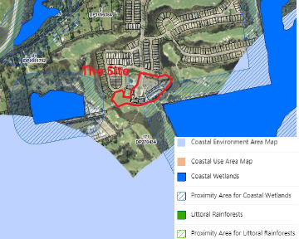
Figure 21: Coastal Map showing coastal wetlands and proximity areas adjacent to the site

Clause 2.7 subclause (1) of the SEPP addresses development on land within coastal wetlands and states that development may be carried out on land identified as “coastal wetlands” only with development consent.

Subclause (2) states that development for which consent is required by subsection (1), other than development for the purpose of environmental protection works, is declared to be designated development for the purposes of the Act.

And subclause (4) states that a consent authority must not grant consent for development referred to in subsection (1) unless the consent authority is satisfied that sufficient measures have been, or will be, taken to protect, and where possible enhance, the biophysical, hydrological and ecological integrity of the coastal wetland or littoral rainforest.

Clause 2.8 addresses development on land in proximity to coastal wetlands and states that development consent must not be granted to development on land identified as “proximity area for coastal wetlands” unless the consent authority is satisfied that the proposed development will not significantly impact on—

(a) the biophysical, hydrological or ecological integrity of the adjacent coastal wetland or littoral rainforest, or
(b) the quantity and quality of surface and ground water flows to and from the adjacent coastal wetland or littoral rainforest.

The application is conflicting with regard to potential impacts on the coastal wetlands and coastal proximity areas. The SEE states that “No works are located on the part of the site mapped as a proximity area” to the coastal wetland, or within the coastal wetland and that there would be no native vegetation removal. However, this is at odds with the Construction Management Plan which details the following works:

- An area of “bushland” is required to be removed adjacent to the proposed building for a crane and lifting zone. This is reflected in the below figure from page 18 of the CMP (purple shaded area in extract below). This area was found during site inspection to include a range of native trees and vegetation, habitat for fauna and included an area of ponded water. It is not clear from the documentation provided whether this area is within the Coastal Wetlands Buffer area.

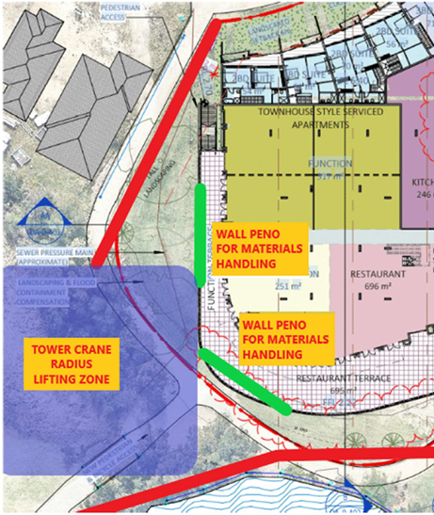
Figure 22: Excerpt from Construction Management Plan (Page 18)

- A “construction materials handling/drop off zone” and construction access is located within the mapped wetland proximity area (see extract below from page 14 of the CMP). The CMP also describes a range of earthworks and construction works in this area to make it suitable for construction machinery, including hardstand areas.

Figure 23: Excerpt from the Construction Management Plan (Page 14)
- Construction access has been proposed from Warner Avenue. There are trees and native vegetation adjoining Warner Avenue. The CMP recommends that “30m of road on approach to the entry/exit gate be cleared and the road temporarily widened to allow for waiting bays for vehicles on either side of the road”. This area is also within the mapped proximity area to the SEPP Coastal Wetland, and possibly within the mapped Coastal Wetland boundary itself. Some of this vegetation is also included in the NSW Biodiversity Values Map, and any clearing of that vegetation would require submission of a BDAR with the development application.

These impacts are not detailed in the SEE and there is no plan detailing the trees or vegetation that may be impacted. In the absence of a comprehensive arborist report and ecological assessment (prepared by suitably qualified professionals) that address the impacts associated with any proposed road widening or upgrade works for the construction access, the impacts on coastal wetlands and coastal wetland proximity areas cannot be considered and assessed (reason for refusal 8).

Chapter 4: Remediation of Land

Clause 4.6 requires the approval authority to consider whether the land is contaminated and if the land is contaminated, it is satisfied that the land is suitable in its contaminated state (or will be suitable, after remediation) for the purpose for which the development is proposed to be carried out.
Further under clause 4.6(2) before determining an application for consent to carry out development that would involve a change of use of land, the approval authority must consider a report specifying the findings of a preliminary investigation of the land concerned carried out in accordance with the contaminated land planning guidelines.
The site has been used in the past for activities which could have potentially contaminated the site. Parts of the site had been used for drum storage, chemical storage areas and areas of coal chitter. The SEE submitted with the application states ‘the site was originally remediated as part of the development of the 2002 Master Plan. … the approved management measures were implemented, and the site certified as suitable for residential development’. No supporting documentation was provided.
Given that there has been contaminating activities in the past and the proposal includes significant excavation it is considered that a preliminary contamination investigation is necessary but has not been provided. Therefore, the requirements of Chapter 4 have not been satisfied (reason for refusal number 11).
State Environmental Planning Policy (Transport and Infrastructure) 2021

Section 2.122 – Traffic-generating development

The proposal includes parking provision for an additional 253 spaces which is a type and scale of development specified under Column 2 of Schedule 3 of SEPP (Transport and Infrastructure) 2021 as a traffic-generating development. Section 2.122 of the SEPP specifies that before determining a development application the consent authority must give written notice of the application to Transport for NSW (TfNSW) and any response received within 21 days is taken into consideration.

The application was referred to TfNSW for comment who advised:

TfNSW has reviewed the information provided and raises no objection to or requirements for the proposed development as it is considered there will be no significant impact on the nearby classified (State) road network.

TfNSW also included the following advice:

Council should have consideration for the cumulative traffic impact of the subject development and other proposed/future developments in this area. It is recommended that an appropriate funding mechanism to be considered to provide an equitable monetary contribution towards future road network upgrades and/or traffic management measures that are likely to be required as a result of the proposed/future developments.

Section 2.122 (4) also requires that before determining a development application for development to which this section applies, the consent authority must take into consideration

(ii) the accessibility of the site concerned, including—
(A) the efficiency of movement of people and freight to and from the site and the extent of multi-purpose trips, and
(B) the potential to minimise the need for travel by car and to maximise movement of freight in containers or bulk freight by rail, and
(iii) any potential traffic safety, road congestion or parking implications of the development.

Council’s Traffic and Transport Engineer has assessed the traffic impacts of the development and has advised that it is anticipated that the proposed development will not have a significant impact on the surrounding road network. While intersection counts were undertaken in 2018, a background traffic growth of 2% has been applied for the 2028 scenario with development traffic. This is acceptable and updated traffic counts are not required. The report indicates that the total additional trips generated by the development will be 76, 55 and 160 in the AM, PM and Saturday peak periods respectively. The Sidra modelling provided indicates that the existing intersections will be capable of accommodating the additional traffic generated by the development. The submitted Traffic and Parking Impact Assessment addresses a number of issues including public transport, walking and cycling and how the use of these alternative transport modes can be encouraged by staff, residents and visitors to the facility. The proposal is satisfactory with regard to meeting the requirements of the SEPP.

Central Coast Local Environmental Plan 2022

The relevant local environmental plan applying to the site is the Central Coast Local Environmental Plan 2022 (‘the LEP’). The aims of the LEP include to promote a high standard of urban design that responds appropriately to the existing or desired future character of areas. The proposal is inconsistent with these aims as the proposal is considered to be out of character with the surrounding area.

Zoning and Permissibility (Part 2)

The site is located within the SP3 Tourist, RE2 Private Recreation and C3 Environmental Management zones pursuant to Clause 2.2 of the LEP.

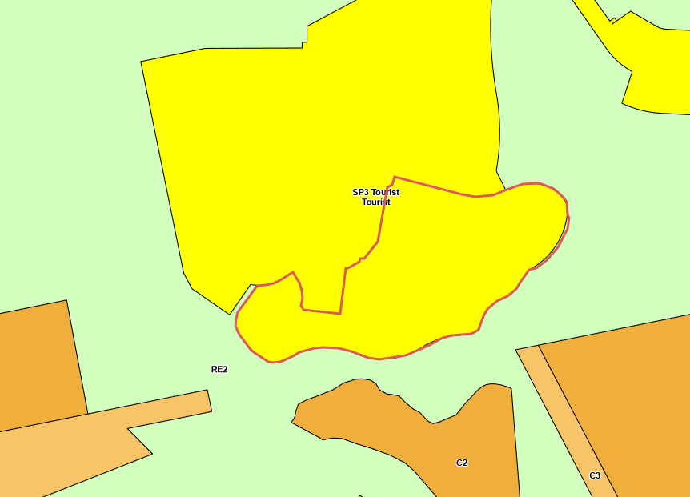
Figure 24: Zoning map
The CCLEP defines the development as:

mixed use development means a building or place comprising 2 or more different land uses.

The proposal seeks consent to construct a mixed use development which incorporates the following uses:

serviced apartment means a building (or part of a building) providing self-contained accommodation to tourists or visitors on a commercial basis and that is regularly serviced or cleaned by the owner or manager of the building or part of the building or the owner’s or manager’s agents.
Note—Serviced apartments are a type of tourist and visitor accommodation—see the definition of that term in this Dictionary.

Note – the applicant has applied for 97 serviced apartments. However, approximately half of the serviced apartments are not self-contained in a manner consistent with the definition. Therefore, it is considered that the proposal includes a mix of serviced apartments and hotel suites. The mix is 51 serviced apartments and 46 hotel suites providing a total of 97 units for tourist accommodation.

hotel or motel accommodation means a building or place (whether or not licensed premises under the Liquor Act 2007) that provides temporary or short-term accommodation on a commercial basis and that—
(a) comprises rooms or self-contained suites, and
(b) may provide meals to guests or the general public and facilities for the parking of guests’ vehicles,
but does not include backpackers’ accommodation, a boarding house, bed and breakfast accommodation or farm stay accommodation.
Note—Hotel or motel accommodation is a type of tourist and visitor accommodation—see the definition of that term in this Dictionary.

tourist and visitor accommodation means a building or place that provides temporary or short-term accommodation on a commercial basis, and includes any of the following—
- backpackers’ accommodation,
- bed and breakfast accommodation,
- farm stay accommodation,
- hotel or motel accommodation,
- serviced apartments,
but does not include—
- camping grounds, or
- caravan parks, or
- eco-tourist facilities.

food and drink premises means premises that are used for the preparation and retail sale of food or drink (or both) for immediate consumption on or off the premises, and includes any of the following—
- a restaurant or cafe,
- take away food and drink premises,
- a pub,
- a small bar.

function centre means a building or place used for the holding of events, functions, conferences and the like, and includes convention centres, exhibition centres and reception centres, but does not include an entertainment facility.

pub means licensed premises under the Liquor Act 2007 the principal purpose of which is the retail sale of liquor for consumption on the premises, whether or not the premises include hotel or motel accommodation and whether or not food is sold or entertainment is provided on the premises.
Note—Pubs are a type of food and drink premises—see the definition of that term in this Dictionary.

Tourist and visitor accommodation (i.e., serviced apartments and hotel accommodation), food and drink premises (i.e., restaurant and pub) and function centres are all permissible uses with consent in the SP3 Tourist zone.

The SP3 Tourist zone objectives are as follows (pursuant to the Land Use Table in Clause 2.3):

- To provide for a variety of tourist-oriented development and related uses.
- To facilitate the provision of limited permanent accommodation in the form of mixed use development to improve the off-season viability of tourist-based development.
- To protect and enhance the natural environment for tourist and recreational purposes.

The proposed development includes tourist and visitor accommodation, and related tourist uses i.e., food and drink premises and function rooms that are consistent with the first objective. However, it is not considered that the proposal to provide 98 residential units (verses 97 tourist units) demonstrates a limited amount of permanent accommodation. To the contrary the number of residential units is greater than the proposed tourist units as is the gross floor area (GFA). In addition, the application does not demonstrate how the proposal protects or enhances the natural environment. There are potential impacts to the wetland proximity area, a coastal wetland and threatened ecological communities. The proposal is inconsistent with the zone objectives (reason for refusal number 2).

The objectives of the RE2 Private Recreation are as follows:

- To enable land to be used for private open space or recreational purposes.
- To provide a range of recreational settings and activities and compatible land uses.
- To protect and enhance the natural environment for recreational purposes.
- To offer opportunities for development for community and tourism purposes that is compatible with the natural environment.

The proposal includes a construction materials handling/drop off zone and tower crane radius lifting zone within the RE2 zoned area of the site (shown approximately as a red circle in the figure below). The works in this area include a temporary hardstand/bearing platform to ensure bearing capacities for heavy vehicles accessing this area can do so in a safe manner. The lake embankment directly adjacent to this zone may also require a civil engineers design to stabilise and upgrade the embankment to enable this area to be used for construction activities. The bushland adjacent to the podium footprint will need to be cleared to maximise usage of this area and to extend the lifting zone to become closer to the site. These activities are considered as ancillary to the proposed mixed use development – however tourist and visitor accommodation, residential accommodation and function centres are all prohibited in the zone. Therefore, the application has failed to demonstrate the permissibility of the proposed works in the RE2 zone in accordance with the relevant permitted uses (reason for refusal number 3).

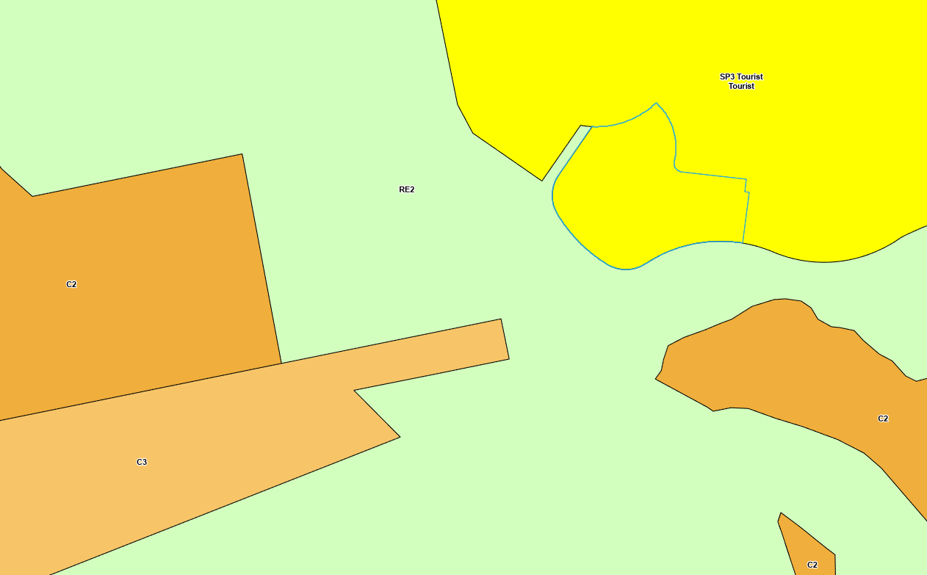
Figure 25: Zoning map showing location for proposed construction activities

The objectives of the C3 Environmental Management zone are as follows:

- To protect, manage and restore areas with special ecological, scientific, cultural or aesthetic values.
- To provide for a limited range of development that does not have an adverse effect on those values.
- To provide a buffer to land of high ecological value or land that has environmental constraints or hazards.

It is proposed to clear vegetation either side of Warner Avenue to enable construction vehicles to access the site. This work is considered as ancillary to the proposed development, however none of the proposed uses are permitted within the C3 zone (reason for refusal number 3). Removal of vegetation is not consistent with the zone objectives as it involves the removal of vegetation having an ecological and aesthetic value. Clearing of native vegetation on a public road is also not considered reasonable when there is an alternative access route through the estate (reason for refusal number 4).

Clause 2.5 Additional permitted uses for particular land

Under clause 2.5 and Schedule 1 of the additional permitted uses within the CCLEP 2022 the subject site is identified under clause 16 – use of certain land at The Entrance North and Wyong. This clause states the following:

16 Use of certain land at The Entrance North and Wyong
(1) This clause applies to land identified as “Magenta Shores” and “Kooindah Waters” on the Additional Permitted Uses Map.
(2) Development for the purposes of residential accommodation is permitted with development consent if the consent authority is satisfied that tourist and visitor accommodation will remain the dominant use on the land as a whole.

The Additional Permitted Uses Map shows the land identified as Kooindah Waters, the subject of the above clause, to be as follows:
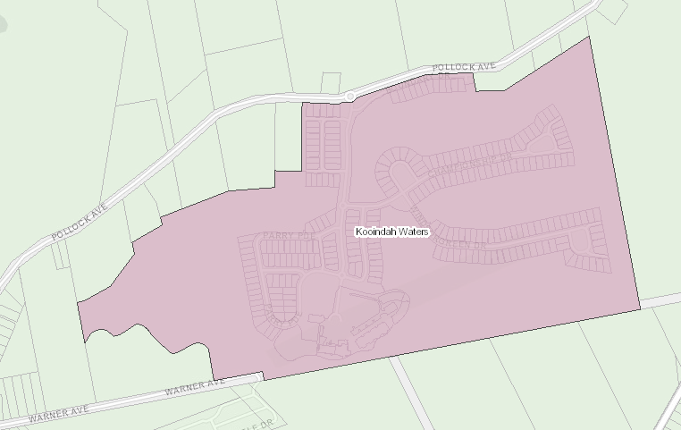
Figure 26: Excerpt from Additional Permitted Uses map in CCLEP 2022
The proposal seeks consent for 98 residential apartments as part of the mixed-use development. Permissibility of the residential accommodation under CCLEP relies on tourist and visitor accommodation being the dominant use. To confirm compliance with this clause, two aspects need to be considered:
- The totality of land uses (existing and proposed) within the mapped area; and
- What constitutes ‘dominant’.
If we turn to the second point first, the Australian Oxford Dictionary (Fifth edition) defines ‘to dominate’ as follows:
1 have a commanding influence over.
2 be the most influential or conspicuous person or thing.
Based on the above definition, it would be expected that the amount of tourist and visitor accommodation within the mapped area would far outweigh the residential accommodation. However, the following table clearly identifies that this is not the case.
Residential Accommodation | Tourism Accommodation
Existing 252 residential lots | Existing 84 tourism units/hotel suites
Proposed 98 residential units | Proposed 97 serviced apartments
Total: 350 | Total: 181

The applicant has incorrectly referred to the lots that are the subject of the proposed tower building and the adjoining golf club house and hotel suites instead of the whole mapped APU area to calculate compliance with Clause 16 of Schedule 1.

The application has failed to provide calculations that clearly demonstrate compliance with the Additional Permitted Use (APU) clause of CCLEP. The SEE does not include the land as a whole which is a requirement of the clause. Insufficient information has been provided to satisfy Council that the proposed development is permissible and based on the above table and outline of uses it is considered that the residential component of the proposal does not satisfy the APU provisions and is therefore prohibited (reason for refusal 1).

General Controls and Development Standards (Part 2, 4, 5 and 7)

The LEP also contains controls relating to development standards, miscellaneous provisions and local provisions. The controls relevant to the proposal are considered in Table 4 below.

Table 5: Consideration of the LEP Controls
Control | Requirement | Proposal | Comply
Demolition requires development consent | Details of proposed demolition are to be included with an application for development consent. | The application includes details of proposed demolition. | Yes
Height of buildings  (Cl 4.3(2)) | No specified height limit under Clause 4.3 (and the Height of Buildings Map) under the CCLEP. | 87.938m | -
FSR  (Cl 4.4(2)) | No specified maximum FSR applying to the site under Clause 4.4 (and the Floor Space Ratio Map) under the CCLEP. | 4.2:1 | -
Heritage  (Cl 5.10) | This clause requires consideration of both European and Aboriginal Heritage | The subject site is not in proximity to any European heritage items or heritage conservation areas. However, an AHIMS search was not submitted with the application to satisfy Aboriginal due diligence in relation to this clause (reason for refusal number 12). | No
Flood planning (Cl 5.21) | This clause requires that the Consent Authority be satisfied as to certain matters specified under the clause. | Kooindah Waters is a flood island during the 1%AEP and the sole access road in Pollock Avenue is estimated to be cut during 1%AEP events. Pollock Road is inundated in a range of flood events. Pollock Road will be cut during the 5%AEP event north of the entrance to Kooindah Waters. The proposed additions and alterations will result in an increased number of people isolated by floodwater. The approved rezoning for Kooindah Waters allowed for a Flood Refuge at the existing hotel during major flood events. The masterplan envisaged a building on the subject site however, did not indicate that the new building would propose such an intensification of population on site. The applicant has failed to demonstrate that the existing flood refuge is appropriately sized for the significant increase in population resulting from the proposed development. Council’s Flood Engineer is concerned that this development will result in a significant increase in risk to life from flooding (reasons for refusal number 16 and 17). | No
Acid sulphate soils  (Cl 7.1) | Clause 7.1 requires assessment to be given to development on land that is mapped as being subject to actual or potential acid sulphate soils. The subject site has been identified as containing potential Class 2. | The site is mapped as containing Class 2 acid sulphate soils (ASS). An acid sulfate soil management plan was provided with the application. The ASS Management Plan (ASSMP) states: “Excavated materials shall be stockpiled in a suitably bunded area with an impermeable base. The location of the stockpiles should be selected to minimise impact on surrounding environment”. However, no specific area of the site is nominated as suitable. The area of the site adjoining the proposed tower is low lying, partially mapped as a buffer to coastal wetlands, environmentally sensitive and likely to be unsuitable for ASS treatment in terms of environmental protection of downstream wetlands (reasons for refusal 8 and 12). | No
Airspace Operations  (Cl 7.4) | Clause 7.4 states that consent cannot be granted without consultation with the relevant commonwealth body | Advice from the relevant body has not been obtained in this instance as the application is not supported. It is noted the applicant’s SEE does not address this clause. | No
Essential services  (Cl 7.6) | Clause 7.6 states that development consent must not be granted to a development application unless the consent authority is satisfied that the services that are essential for the development are available or that adequate arrangements have been made to make them available. | Although the site benefits from reticulated services, information has not been provided to demonstrate capacity of the existing systems (water and sewer) to accommodate the increase demand under the proposal. Consent of the Community Association for the use of roads and utilities is also not provided (reason for refusal number 17). | No

The proposal is considered to be inconsistent with the LEP.

- Section 4.15 (1)(a)(ii) - Provisions of any Proposed Instruments

- Draft Remediation of Land SEPP

The key operational framework of the former SEPP 55 which has been replaced by SEPP RH is maintained in the new SEPP which will still require consent authorities to consider whether the site is, or is likely to be, contaminated, and permit a consent authority to require additional information to satisfy itself as to whether the land is contaminated. Having regard for the Explanation of Intended Effect, and the site history, the proposed development is considered to be unsatisfactory with regard to the draft SEPP.

- Section 4.15(1)(a)(iii) - Provisions of any Development Control Plan

The following Development Control Plan is relevant to this application:

Central Coast Development Control Plan 2022 (‘the DCP’)

The following Chapters of Central Coast Development Control Plan 2022 (‘the DCP’) are relevant to this application:

- Chapter 1.2: Notification of Development Proposals
- Chapter 2.3: Residential Flat Buildings
- Chapter 2.13: Transport and Parking
- Chapter 2.14: Site Waste Management
- Chapter 3.1: Floodplain Management and Water Cycle Management

CCDCP 2022 Chapter 1.2: Notification of Development Proposals

The proposal was notified in accordance with Chapter 1.2 Notification of Development Proposal of the Central Coast DCP from 23 September 2022 until 24 October 2022.

The application was renotified from 18 November 2022 to 16 December 2022. The application was re-notified to clarify that the proposal includes a 26-Storey Mixed Use Building (not 24) and that construction access is proposed via Warner Avenue, Wyong.

The Council received a total of 106 unique submissions, comprising 104 objections and two submissions in favour of the proposal. The issues raised in these submissions are considered in Table 8.

CCDCP 2022 Chapter 2.3: Residential Flat Buildings

Chapter 2.3 of CCDCP 2022 applies to the proposed residential apartments component of the development and a summary of compliance with the relevant controls under the Chapter are outlined under the attached table (Attachment X). However, there are a number of requirements under the DCP that are relevant to the proposal but overridden by similar controls contained within the ADG. These DCP requirements include:

- communal open space (10m² per dwelling with a minimum dimension of five metres);
- private open space (a minimum area of 10m² and a minimum dimension of two metres);
- deep soil provision (12.5% site area), site coverage (soft landscaping 25%);
- solar access (minimum of 3 hours midwinter between 9am-3pm for 70% dwellings);
- building separation; and
- storage (3m² of floor area/1-2 bed dwelling).

The DCP requirements relevant to the proposal that are not provided within the ADG include the following:

Building height

Under clause 2.3.3.1 where a maximum building height for a site is not identified in the height maps under CCLEP 2022, the development shall not exceed 2 storeys in height. The proposed tower has a total of 26 storeys and 17 storeys dedicated to residential unit accommodation and therefore fails to comply with the requirements of this clause (1200% variation).

The objectives of the clause are as follows:

- To ensure that buildings are compatible with the existing and desired future character of the locality
- To ensure that the height of buildings protects the amenity of neighbouring properties in terms of visual bulk, access to sunlight, privacy and views
- To ensure that building height is not visually obtrusive, is compatible with the scenic qualities of hillside and ridgetop locations and respects the sites natural topography

The proposed development results in a building height which is excessive for the site and does not fit with either the existing or desired future character of the locality. The proposed development is 26 storeys high, and the overall building height is 87.938m to the roof top.

The existing area is characterised by low density residential development in a landscaped setting with a small portion of commercial development in the form of a three-storey golf club and associated two and three storey serviced apartments. The site is surrounded by the golf course and system of wetlands that make up the Kooindah Waters Estate. Broader afield is a manufactured home estate to the south-west and rural residential development on large lots. It is considered that the desired future character is the continuation of the existing character, as there are no proposals to rezone the area.

In determining whether the design of the development is compatible with the character of the local area, consideration was given to the planning principle of Project Venture Development Pty Ltd v Pittwater Council [2005]. Compatibility is seen to be a measure of the ability to exist together in harmony. It is not a test of sameness. It is generally accepted that buildings can exist together in harmony without having the same density, scale or appearance, though as the difference in these attributes increases, harmony is harder to achieve. To establish compatibility with the character of the local area, the following questions were considered by the Commissioner in that matter:

- Are the proposal’s physical impacts on surrounding development acceptable?
- Is the proposal’s appearance in harmony with the buildings around it and the character of the street?
The physical impacts, such as noise and overlooking can be assessed with relative objectivity. In contrast, to decide whether or not a new building appears to be in harmony with its surroundings is a more subjective task. Analysing the existing context and then testing the proposal against it can, however, reduce the degree of subjectivity.

Turning to the first question, it is considered that the proposed development will result in unacceptable physical impacts on surrounding development. These impacts include visual impacts, overlooking, acoustic impacts, parking impacts, ecological impacts, and adverse impacts on the streetscape.

Visual impacts – the visual impact of the proposal is a major concern raised by submitters. The height, bulk and scale are in stark contrast to its surroundings and would result in a substantially altered character of the area.

The planning principle in Veloshin v Randwick Council [2007] NSWLEC 428 considered whether the height, bulk and scale of a proposed development is acceptable. The principle states that the appropriateness of a proposal’s height and bulk is most usefully assessed against planning controls related to these attributes, such as maximum height, floor space ratio, site coverage and setbacks. The questions to be asked are:

- Are the impacts consistent with impacts that may be reasonably expected under the controls? How does the proposal’s height and bulk relate to the height and bulk desired under the relevant controls?

- Does the area have a predominant existing character and are the planning controls likely to maintain it? Does the proposal fit into the existing character of the area?

The impacts associated with the proposed development are not consistent with the impacts that may be reasonably expected of a building with a maximum height of two storeys, as required by the DCP. The proposal with a height of 26 storeys will result in adverse visual impacts, overlooking, acoustic impacts, parking and ecology impacts as well as adverse impacts to the streetscape and character of the locality. It is considered that development of a two-storey development would be acceptable in the location, as it would complement the three-storey golf club and serviced apartments development to the east. A maximum three storey building was also envisaged on the location in the 2002 Master Plan.

With a maximum of two stories, the planning controls in the DCP maintain the existing character which is low scale in nature and dominated by one and two storey developments. The proposed development is contrary to this.

The proposed development does not ‘fit’ into the existing character as the height, bulk and scale of the proposal are completely out of context and visually dominate everything else in the locality. The proposal will dominate the views to and from the area and no amount of landscaping would assist in softening the view of the development. The locality would experience adverse visual impacts that would otherwise not result from a compliant two storey development.

The potential visual impact on adjoining public open spaces and residential areas is strongly influenced by the relative size of the building and distance from the viewer. There are very minimal setbacks proposed between the proposed tower and adjoining development and the golf course. The development will therefore result in a high visual impact upon from within the estate and users of the golf course.

The proposal would have a high degree of visibility from various vantage points across the landscape. It is anticipated that the development would be visible from as far south as The Entrance and west to the Wyong town centre. The images below indicate some view scenarios. It can be clearly seen that the development is completely out of context with its surroundings and the streetscape.

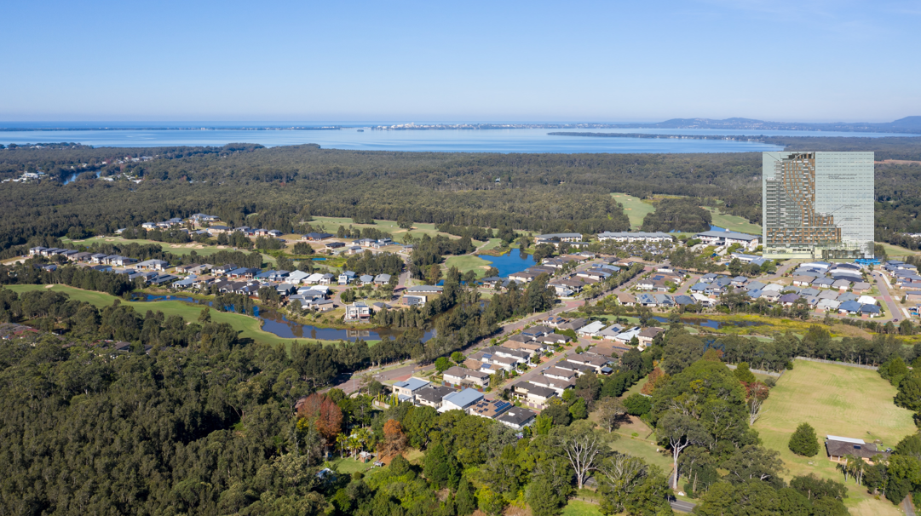
Figure 27: View looking south with proposed tower superimposed
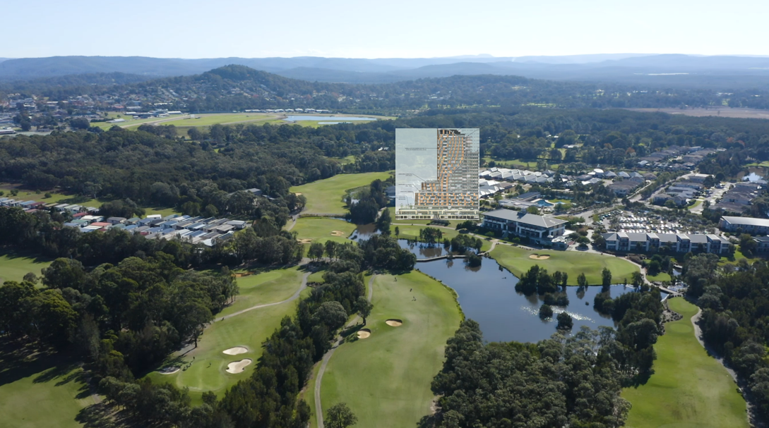
Figure 28: View looking north with proposed tower superimposed

Overlooking – the proposal fails to comply with the separation requirements for visual privacy in the ADG. At ground level the development is setback 3.190m instead of 6m to the adjoining dwelling to the west. The upper floor plan is also setback 3.3m to the same dwelling instead of the required 6m. While the residential units within the tower itself are setback in compliance with the ADG separation requirements, any sense of visual privacy is diminished by the sheer number of proposed occupants within the development that will overlook the dwellings within the estate. The development is out of context and will result in a feeling of being overlooked by the neighbouring dwellings.

Acoustic impacts – acoustic impacts will result from use of the outdoor swimming pool area and associated deck. This area of the development overlooks adjoining residential dwellings and will result in adverse noise impacts on neighbours. The acoustic report has failed to demonstrate that the proposal will not impact neighbours.

Traffic and parking impacts – the proposal has not demonstrated that there is adequate parking or access provided to support the proposed development. The significant variation to parking is not supported and the development should provide an additional entry/exit to the car park area.

Light spill – concern is raised in regard to potential light spill impacts on adjoining residential dwellings from construction of the proposed tower. Lighting late into the night could impact the sleeping patterns of adjoining residents. No information to mitigate lighting impacts has been provided.

Ecological impacts – construction and ongoing use of the tower may result in unacceptable environmental impacts including on coastal wetlands and endangered ecological communities. Permanent and ongoing dewatering has the capacity to impact downstream wetlands as does acid sulfate soils.

Streetscape - The height, bulk and scale of the proposed development is incompatible with its setting and will have an adverse amenity impact on the character of the street.

In regard to the second question in Project Venture Development Pty Ltd v Pittwater Council [2005], there are no other developments of a comparable size in the local area. The proposal’s appearance is in stark contrast to the buildings around it and the character of the street. Apart from the three-storey commercial development to the east, the area is characterised by low scale residential development. The proposed building does not take any cues from existing development around it, including the golf club building. The styles are in opposition. On this basis, it is considered that the proposal’s appearance is not in harmony with the buildings around it and the character of the street.

On the basis of the above, the proposal is not compatible with the existing or desired future character of the locality. The height of the building does not protect the amenity of neighbouring properties and the proposed building height shall be visually obtrusive. It fails to comply with the objectives of Clause 2.3.3.1 and the variation is not recommended for support (reason for refusal number 13).

Floor space ratio

Under Clause 2.3.3.2, the maximum floor space ratio for development proposals that are located on land not included in the Floor Space Ratio Map of Central Coast LEP 2022 is 0.6:1. The gross floor area of the residential component of the tower is 11,173m² and the area of the site is 4,831m². Accordingly, the FSR of the residential component of the project is 2.3:1 which exceeds that permitted by the DCP.

The relevant objectives are as follows:

- To have development sites and densities that are appropriate in the zone and compatible with the local context
- To ensure building bulk and scale provisions are compatible with neighbouring development

Density is one of the design quality principles of SEPP 65 and accordingly the density of the proposal has been addressed above in detail in this section of the report.

If the 98 dwellings in the proposed development is added to the existing 252 dwellings, the total number of dwellings in the estate increases to 350. The net residential density increases to 17.3 dwellings per hectare. The proposed development brings the density up from a typical low density suburban residential area to one that is more like a village or town centre. Bearing in mind that the hotel rooms have not been included in any of the calculations.

However, the estate does not have any facilities or services that a village or town centre has. The proposed density is not appropriate to the site as it does not have access to the infrastructure, public transport, facilities, retail and services that is required to support the density. In addition, there is a discord between the density of a low-density residential subdivision and a 26 storey tower that is 11 storeys bigger than any existing tower on the Central Coast.

The FSR contributes to the bulk and scale of the development which have been discussed above. The bulk and scale of the proposed development results in unreasonable neighbour impacts and is incompatible with the character and streetscape of the area.

The proposal is inconsistent with the objectives for floor space ratio under the DCP (reason for refusal number 13).

CCDCP 2022 Chapter 2.13 – Transport and Parking

The DCP requires car parking for the development to be provided at the following rates:

Land Use | Requirements
Residential Flat Buildings | Not within 400m of a train station | 1.5 spaces per dwelling
 | Visitor spaces | 0.2 spaces per dwelling, rounded up to the next whole number
Hotel (Pub) or Motel accommodation and Serviced Apartments |  | 1 space per accommodation unit, plus 1 space for every 2 persons employed in connection with the development and on duty at any one time
Restaurants |  | Whichever is greater of:  15 spaces per 100m² GFA  Or 1 space per 3 seats
Pub/Registered Club | Gross floor area up to 5000m² (including outside seating areas) | 1 space per 10m²

Based on the above parking for the proposal is required as follows:

- Residential component – 167 spaces (147 parking spaces + 20 spaces for visitors)
- Hotel accommodation – 146 spaces (97 for hotel suites + 49 spaces for staff as per the detail of staff in the plan of management)
- Restaurant – 105 spaces (based on one restaurant with GFA of 696m²)
- Pub/Registered Club – 217 spaces (the “club” part of the development could be regarded as the bars, function rooms, meeting rooms, and the restaurant outdoor terraces. The gym, bathrooms, pool and pool terrace haven’t been included as this could be seen to be part of the hotel/serviced accommodation and residential towers amenity areas. Total “club” area is 2,169m²)

This results in a total parking requirement of 635 parking spaces. The application proposes an additional 253 parking spaces which represents a shortfall of 382 or a variation of 60%.

A Traffic and Parking Impact Assessment report, prepared by The Transport Planning Partnership and dated 29 March 2019 was provided with the application.

The TIA was reviewed by Council’s Traffic Engineer who found the report to be unsatisfactory for the following reasons:

- It is based on data collected in 2018 and 2013 (car parking study). The traffic report needs to be updated to reflect current scenarios and background traffic growth including cumulative effect of proposed and approved developments within the vicinity of the site.
- Insufficient information has been provided to demonstrate the complimentary nature of the various land uses in regard to car parking.
- The site benefits from only one existing loading dock located at the lower ground level of the existing building. The TIA states that a management system should be implemented to ensure that the loading demand does not exceed the capacity of the dock (eg, a booking system). However, this is considered insufficient for a development of this size and nature.
- The TIA details that the management of traffic and parking should be based on a proposed travel plan that proposes measures to both limit the population on site and influence the travel patterns of those people visiting the development with a view to encouraging modal shift away from cars
- The report recommends provision of a temporary on-site overflow car park for special events – however no detail is provided as to where this would be proposed.
- The TIA conflicts with the submitted construction management plan in that it states that construction vehicle access is expected to occur from Parry Parade via Kooindah Boulevard and Pollock Avenue. However, it is unlikely that a semi-trailer would be able to traverse the Pollock Avenue roundabout without alterations made to it.
- The report states that it is envisaged that dedicated parking will be provided for construction workers within this estate but fails to detail where this parking would be located.

Council’s Traffic Engineer also raised a critical issue with regard to vehicle access. Vehicle access to the car park is proposed to be provided via the existing car park located under the golf club with access from Kooindah Boulevard. This will result in only one entry in and one entry out of the car parking area for the development – the same entry/exit for the existing golf club. The proposed car park is to be connected to the existing car park at ground level. Council has concerns that for 253 car parking spaces, there is only one entry and exit point through the existing car park where there is a dedicated servicing bay/loading dock. It would be expected that another entry and exit be provided to improve circulation and traffic flow and to avoid traffic conflicts within the carpark area.

CCDCP 2022 Chapter 2.14 Site Waste Management

The applicant has submitted a Waste Management Plan (WMP) in accordance with the requirements of this Chapter. The report was prepared by Barker Ryan Stewart and is dated March 2019. The WMP is based on the former Wyong Waste Control Guidelines. While the current Central Coast Waste Control Guidelines is the correct document to refer to the same requirements apply under both the former and existing guidelines in regard to waste management for mixed use developments.

Mixed use developments must incorporate separate and self-contained waste management systems for the residential component and the non-residential component. In particular, the development must incorporate separate waste/recycling storage rooms/areas for the residential and non-residential components. Commercial tenants must be prevented from using the residential waste/recycling bins and vice versa.

The waste infrastructure, management plans, handling methodology and collection systems must be designed to and demonstrate that, all domestic and non-domestic waste is managed, stored, and collected separately. There are often serious problems with commercial tenants using the residential waste facilities (or vice versa) in mixed use developments, which can cause overloading of the waste management system, unhygienic conditions and disputes over payment for collection.

The WMP states that the residential waste will be managed by the hotel and treated as commercial waste. The proposal is to provide a temporary waste collection area for the residential waste within the ground floor carpark, which is transported to the main collection area for servicing. The main collection area encompasses both the residential and commercial bins in the one enclosure. This arrangement is contrary to the guidelines and cannot be supported.

Under the guidelines, the waste collection point should not be located near an intersection or where they pose a traffic hazard and the collection point should be located so that collection vehicles do not interfere with the use of access driveways, loading bays or parking bays during collections.

The proposed waste storage and collection room is located adjacent to the main entry and exit to the development. This results in conflict between waste trucks and vehicles accessing and leaving the carpark. No traffic control measures have been provided to manage this conflict. In any event, it would be preferable for the waste collection room and main access driveway to be physically separated and this would require a substantial redesign.

A further concern is the location of the separate temporary storage area for residential waste which needs to be wheeled through the carpark to the main collection point. Concern is raised about the safety of this arrangement which requires transporting bins through the main entry/exit to the development to the main waste collection point.

The proposal has failed to demonstrate how the waste collection area is to be serviced. Swept paths for a heavy rigid vehicle have not been provided to confirm there is adequate area to enter the carpark, manoeuvre and exit in a forward direction.

The proposal fails to comply with Council’s Waste Control Guidelines, and safety concerns are raised by the proposed waste management arrangements (reason for refusal number 13).

CCDCP 2022 Chapter 3.1 – Floodplain Management

Kooindah Waters is a Flood Island during the 1%AEP event (refer figure 18 below). While the suburb is filled above the 1%AEP flood level, the sole access road in Pollock Ave is estimated to be cut during the 1%AEP event. Pollock Road is inundated in a range of flood events. Pollock Road will be cut during the 5%AEP event north of the entrance to Kooindah Waters.

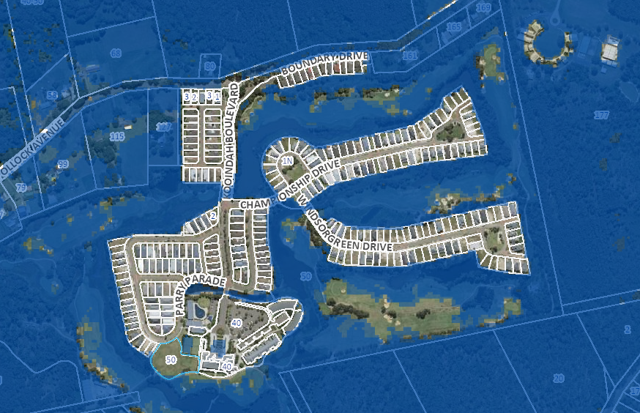
Figure 29: Flood Extents 1 in 100 Year
The site is identified as Precinct 2 (flood planning area) where proposals for medium to high density residential and tourism developments are required to provide a performance based assessment demonstrating that the proposed development is compatible with the flooding characteristics of the site.

The proposal will result in an increased number of people isolated by floodwater and the applicant has failed to demonstrate that all additional residents in Kooindah Waters would have safe refuge during major flood events. A suitable Performance Based Assessment in accordinace with CCCDCP 2022 Ch 3.1.4.1 which demonstrates the suitability of the proposal has not been provided. The Performance Based Assessment would need to address all necessary provisions and actions in case of medical emergency or loss of essential services and would need to demonstrate why and how the development satisifies clause 5.21 Flood Planning of CCLEP 2022. It is noted that the original masterplan required provision of a helicopter landing facility for medical emergencies with access to the major site buildings. No information about the helicopter pad has been provided.

Council’s Flood Engineer also highlighted concerns about the flooding of the basement carpark during the PMF event. Improvements to the design would be required which would eliminate flooding of the basement carpark during the PMF.

Contributions Plans

The following contributions plans are relevant pursuant to Section 7.18 of the EP&A Act and have been considered in the recommended conditions (notwithstanding Contributions plans are not DCPs they are required to be considered):

- Wyong District S7.11 Development Contributions Plan 2020

This Contributions Plan has been considered and would be included as a recommended condition of consent if the proposal was recommended for support.

- Section 4.15(1)(a)(iiia) – Planning agreements under Section 7.4 of the EP&A Act

There have been no planning agreements entered into and there are no draft planning agreements being proposed for the site.

- Section 4.15(1)(a)(iv) - Provisions of Regulations

The Environmental Planning and Assessment Regulation 2021 (2021 EP&A Regulation) commenced on 1 March 2022 and replaced the 2000 Regulation.
Clause 92(1) of the Regulation contains matters that must be taken into consideration by a consent authority in determining a development application. Demolition works are identified under the clause and are proposed under the application. The demolition works would need to be carried out in accordance with the provisions of AS 2601, however the proposal is recommended for refusal.
  - Section 4.15(1)(b) - Likely Impacts of Development

The likely impacts of the development, including environmental impacts on both the natural and built environments, and social and economic impacts in the locality must be considered. In this regard, potential impacts related to the proposal have been considered in response to SEPPs, LEP and DCP controls outlined above and the Key Issues section below.

The consideration of impacts on the natural and built environments includes the following:

Context and setting

Context refers to the setting of a development, including both the existing physical surroundings and the planned vision for the future of an area.

The existing physical surroundings are those of the estate and the surrounding local area. The estate is comprised of the fairways of the golf course, the hotel complex, accommodation and facilities, the low scale residential areas, the tree-lined streets, and the natural and constructed waterways and vegetation. The local area has low scale vegetated semi-rural acreages with dwellings and large areas of natural vegetation and wetlands.

In regard to the planned vision for the future of the area, this is not proposed to change. The North Wyong Shire Structure Plan (released in 2012) sets out planning priorities and opportunities to develop new homes, jobs and communities. While this plan identifies the Warnervale-Wadalba Land Release area which is located north of the site as a key priority, there are no proposals to develop the greenfield land around Kooindah Waters. Therefore, the site is not subject to any transition in character or change from low density residential to a higher density precinct.

The proposal is for a high, bulky building that does not respond to the existing surrounding context. The predominant character is of low-rise buildings set within waterways, green fields, trees and vegetation. The site is within a relaxed setting of a private estate with a unique community sharing facilities. A large tower block building does not site well within this setting. Due to its large size, the tower block building will be visible from many vantage points in the surrounding context and will stand out as something foreign to the area.

The site is not within a town or city where higher density development is more common. The site is not located in close proximity to public transport which can support higher density development. The site does not have many of the services and amenities required by people living in high density apartments.

Locality and streetscape

The locality is the site and its immediate surroundings which forms the streetscape. The site has frontage to Parry Parade as it’s only street address. The other boundaries of the site are to the existing hotel and the fairways of the golf course.

The proposed address to Parry Parade is with 5 two-storey townhouses. The townhouses on their own provide an appropriate address to this minor street. However, behind them is the large bulky tower development that is grossly over-scaled compared to the surrounding two-storey residential development and the existing three-storey hotel. In addition, there is no obvious pedestrian or vehicular entry to the hotel from Parry Parade, which is confusing and does not assist in providing a street identity to the proposed development. The large bulky tower overlooks Parry Parade and the surrounding residential development and will detract immensely from the existing streetscape.

The other sides of the development at ground level all conceal extensive areas of car parking. There are unarticulated walls fronting the golf course with car park ventilation grills. There is no relationship between the activity of the golf course and the concealed car parking. The only accesses to the upper storey terrace of the proposed development are via staircases, which is inaccessible for parents with prams, mobility scooters and wheelchairs. The proposed development makes no contribution to the locality and streetscape in the public domain.

Built form

The proposal does not use a built form that relates to the site, the existing hotel buildings, or the low-density residential character of the area.

While it is noted that the development includes two storey town houses facing Parry Parade, the rest of the development has no transition in height from the existing two storey residential development and the existing three storey golf club up to the proposed large tower building. There is an abrupt change in height from a maximum of three storeys up to 26 storeys.

The base of the building should address the public realm, articulate entrances and minimise the impact of parking and servicing on the streetscape. However, the proposed base of the building fails to include an entrance (entry is through the adjacent golf club building) and instead has ventilation grills surrounding three sides.

Although there has been an attempt to articulate the facades and step the building form in, the overall bulk and scale of the building is overwhelming and grossly out of context and character with the local area. The bottom 3 storey podium and the two storey townhouses are the only elements that have a relationship with the existing hotel and residential buildings. But these elements do not conceal, mitigate or support the bulk of building that emerges above. The proposed development appears quite alien in the local environment. There is no sense that the building has been informed by its location, and it is as if it was designed for a high-density city and then relocated to the site.

On streets characterized by a residential character, at grade related residential units, such as townhouses, can create a pleasant and animated base building alternative, broaden the range of housing choices, and increase the opportunity for social interaction and natural surveillance. Townhouses serviced by an internal driveway would appear to be a much better fit for the site in terms of built form.

For sites where the adjacent context is lower-scale and not anticipated to change, it is important to provide a transition in the base building height down to the lower-scale neighbours. Match at least a portion of the base immediately adjacent to the lower-scaled context with the scale and height of neighbouring buildings. This has been done to a certain degree with the bottom 3 storey podium and the two storey townhouses, but a more appropriate built form is required on the levels above.

Traffic, access and parking

A Traffic and Parking Impact Assessment prepared report by The Transport Planning Partnership was submitted with the development application. Council’s Traffic and Transport Engineer has assessed the traffic impacts of the development and has advised that it is anticipated that the development will not have a significant impact on the surrounding road network. While intersection counts were undertaken in 2018 a background traffic growth of 2% has been applied for the 2028 scenario with development traffic. This is considered to be acceptable and updated traffic counts are not required. The report indicates that the total additional trips generated by the development will be 76, 55 and 160 in the AM, PM and Saturday peak periods respectively. The Sidra modelling provided indicates that the existing intersections will be capable of accommodating the additional traffic generated by the development.

The Traffic and Parking Impact Assessment report states the following with regard to car parking – ‘the proposed individual uses in the development would require a total of 486 car parking spaces if each use was considered as a stand-alone use. However, as shown by the analysis of the existing site use demand presented above, the proposed land uses are considered to be complementary with visitors using multiple facilities in one visit’.

The report has incorrectly assessed the amount of car parking that is generated by the development as under the CCDCP 635 car parking spaces are required and the proposal of 253 therefore represents a 60% variation. While it is accepted that there would be a high degree of cross purpose trips it is considered that the parking report has not adequately justified the significant variation. It has based its assumptions on 2013 survey results which are considered to be out of date and should be revised to take account of the current situation on the site. It also recommends that travel demand management measures be implemented to ensure that cumulative parking demands do not exceed the supply.

Council’s Transport Engineer and Senior Development Assessment Engineer have both advised that a second entry should be provided to the basement car park. Safety issues will likely result from the proposal to locate all the car parking through one existing entry/exit.

The application does not include the submission of swept turning paths for all waste vehicle
manoeuvring designed and certified to AS 2890.2 to demonstrate the ability of the required
waste vehicle to forward enter, access the waste servicing location and forward exit the site.

Amenity

The proposal has not demonstrated that a good design has been achieved to provide a high level of amenity for residents and visitors and each apartment, particularly in relation to solar access, natural cross ventilation and private open space.

The non-compliance with both the floor space ratio and building height controls of the DCP results in an undesirable built form outcome that does not respond to the site constraints or surrounding development.

Privacy
The proposed development includes 97 serviced apartments and 98 residential apartments all with balconies. While the setbacks of the residential levels of the development to neighbouring residential dwellings complies with the numerical controls in the ADG, any sense of visual privacy is diminished by the sheer number of proposed occupants within the development that will overlook the dwelling within the estate. The development is out of context and will result in a feeling of being overlooked by the neighbouring dwellings.

The proposal results in significant privacy and overlooking impacts to neighbouring properties as a result of the building height, and the proposed landscaping will not provide any value in mitigating privacy impacts of the development.

Overshadowing

Shadow diagrams have been prepared for the development between 9:00am and 3:00pm, for 21 June (midwinter) in order to demonstrate the worst-case scenario for solar access on the shortest day of the year. The diagrams indicate that most impacted area is the adjoining golf course to the south. The proposal complies with the solar access requirements of the DCP in regard to neighbouring properties.

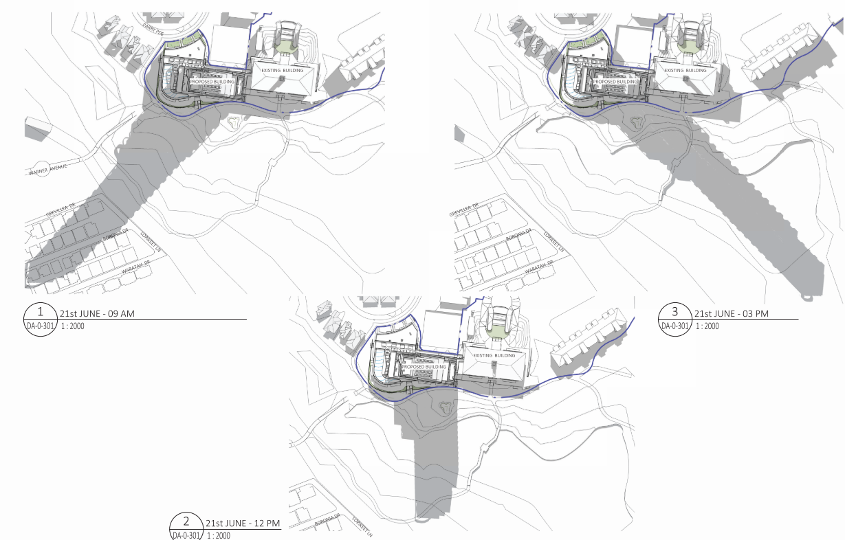
Figure 30: Overshadowing diagrams
Stormwater and drainage

The concept Water Cycle Management Plan prepared by BG&E consulting civil engineers was reviewed and found to be acceptable subject to standard details that would ordinarily be required at Construction Certificate stage.

Heritage
The subject site is not in proximity to any items of European heritage items or heritage conservation areas. However, an Aboriginal Heritage Due Diligence assessment has not been undertaken.

Acid sulfate soils (ASS) and groundwater
The site is mapped as containing Class 2 acid suflate soils (ASS). Under this clause works below the natural ground surface on Class 2 land requires preparation of an ASS management plan.

An acid sulfate soil management plan was provided with the development application. Potential and actual ASS will be encountered during the proposed development. No suitable area on site has been nominated for treatment of acid sulphate soils. The ASS Management Plan (ASSMP) states: “Excavated materials shall be stockpiled in a suitably bunded area with an impermeable base. The location of the stockpiles should be selected to minimise impact on surrounding environment”. However, no specific area of the site is nominated as suitable. The area of the site adjoining the proposed tower is low lying, partially mapped as a buffer to coastal wetlands, environmentally sensitive and likely to be unsuitable for ASS treatment in terms of environmental protection of downstream wetlands.

The ASSMP details that groundwater likely to be intercepted on site was found to be acidic, and that dewatering was likely to be required during construction and then ongoing in relation to the basement. The report suggests a number of potential options for removal or treatment of acidic groundwater, including overland discharge as one option, but no details are given of the proposed option. Therefore, impacts on downstream wetlands cannot be assessed.

Likely interception of groundwater and ongoing dewatering as outlined in the ASSMP could lead to longer term impacts on nearby groundwater dependant ecosystems, including Endangered Ecological Communities and SEPP Coastal wetlands. The Water Cycle management plan states the dewatering may need to be permanent.

Contamination

The proposal is not supported by a preliminary site investigation report. Given the significant extent of excavation and soil disturbance proposed at the site, investigation would be required prior to any significant construction occurring on the site, that any likely remediation could be undertaken, and the site made suitable for the intended use.

Safety, Security and Crime Prevention

The proposal does not generate any concern having regard for the principles of Crime Prevention Through Environmental Design (CPTED). The police were consulted but did not provide any comments.

Flooding impacts

Kooindah Waters is a Flood Island during the 1%AEP event. While the suburb is filled above the 1%AEP flood level, the sole access road in Pollock Ave is estimated to be cut during the 1%AEP event. Therefore, the proposal will result in an increased number of people isolated by floodwaters. Criticially, the proposal needs to incorporate appropriate measures to manage risk to life and property from flood. The approved rezoning for Kooindah Waters allowed for a Flood Refuge at the existing hotel during major flood events. While the Master Plan envisaged a building on the subject site, it did not anticipate that the new building would propose such an intensification of population on site. It is unclear whether the existing Flood Refuge is appropriately sized for the significant increase in population resulting from the proposed development.

Council’s Flood Engineer is concerned that this development will result in a significant increase in risk to life from flooding. The applicant has failed to demonstrate that all additional residents in Kooindah Waters would have safe refuge during major flood events. A suitable Performance Based Assessment in accordinace with CCCDCP 2022 Ch 3.1.4.1 which demonstrates the suitability of the proposal has not been provided.

Insufficient information has been provided in regard to floodplain management.

Public domain

A new footpath, landscaping and civil works are proposed. The proposal includes refurbishment of the existing golf club building which will provide public benefit. The new tower is situated to the west of the existing main hotel building and thus it does not have a direct public domain interface as the entry to the tower is via the existing golf club building.

The proposal includes a new pedestrian access from Warner Avenue to the estate. However, this may conflict with golfers traversing the 18th fairway. Currently there are signs to keep pedestrians off the golf course and physically safe from golfers’ numerous stray shots. This route puts any pedestrian in harm’s way and should be omitted.

The management plan states that the proposed restaurant and bars will be open to the general public.

Bushfire impacts

The NSW Rural Fires Service granted a Bushfire Safety Authority on 16 December 2022 and included the following requirements:

- A Bush Fire Emergency Management and Evacuation Plan is required

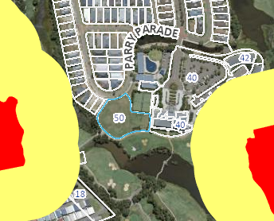
Figure 31: Bushfire prone land map
Social impacts

A social impact assessment (SIA) was not provided with the application. It is expected that an SIA with comprehensive community consultation and mitigation measures to address potential adverse social impacts arising from the development would have been provided for this level of development.

Significant non-compliance’s with the height and FSR controls and the design of the development, result in an undesirable urban form that is not consistent with the existing or desired future character of the area.

The application has not provided sufficient information to demonstrate that the development has appropriately responded to the site constraints or how the development provides a high level of amenity for its occupants and neighbours. The proposal has therefore not demonstrated the immediate and long-term social benefits of the proposal.

Noise
The proposed Plan of Management confirms that the hotel and reception will operate 24 hours per day, 7 days per week. The podium restaurant will operate from 7am to 12 midnight, 7 days a week and use of the outdoor restaurant areas will cease at 11pm. The hours of operation of the function centre are 8.30am to 12 midnight, 7 days a week. The hours of operation of the Sky Bar are 12noon to 2.00am, 7 days a week. The hours of operation of the swimming pool, deck and gym will be 6am to 10pm, 7 days a week. Therefore, there are multiple opportunities for noise impacts on neighbours especially in the evenings.

Council’s Senior Environmental Health Officer has reviewed the submitted acoustic report and states that the information contained therein is insufficient. The following comments were provided:

I have reviewed the sampling data, methodology and findings of this acoustic assessment and I am of the opinion that the NIA failed to address the following considerations:

- Potential impacts of mechanical plant on future residents and surrounding properties,
- Potential impacts of Construction noise on surrounding properties,
- Potential impacts from Waste collection and Deliveries on surrounding properties Potential impacts from amplified sound eg. Music, live bands and entertainment on future residents and surrounding properties,
- Incomplete display of predictive results Table 5-4, eg. Exceedances for Parry Pde,
- Clarity on worst case scenario predictions for patrons in reference to Chap 5.3.3 & Table 5-3

The applicant has provided insufficient information to confirm that the noise impacts of the development will be acceptable.

Economic impacts

The applicant provided an Economic Impact Assessment report dated March 2019. The proposed development would generate short term economic stimulus through the construction of the development. The long-term economic benefit of the development is identified as the generation of 102 jobs, which are additional local employment opportunities being created.

Having regard for the Central Coast Regional Plan 2041, the proposal achieves a core aim in that it facilitates economic development that will lead to additional local employment opportunities on the Central Coast and reduce the percentage of employed persons who travel outside the region each day for work.

In addition, the tourism dollar being spent within the central coast local government area would also provide an economic benefit.

However, no information has been provided about the integration of tourist and residential uses on the site, or the need for premium high-rise apartments within Wyong. Further information is required to identify the current patronage/level of usage of the golf course that generates the need for additional tourist and residential accommodation.

Natural environment

The proposal has the potential to impact threatened ecological communities and coastal wetlands from construction activities, management of acid sulfate soils and dewatering. Insufficient information has been provided to confirm the level of impact or how impacts will be mitigated.

Air quality

It is considered that dust control during demolition, earthworks and construction could be achieved through the adoption of appropriate measures to minimise dust into the surrounding environment.

Water and sewer

The application was referred to Council’s Water and Sewer Assessment Team who advised the following:

- Water supply - water is available to the proposed development as an existing 150mm water main is fronting the proposed development site. The applicant is required to obtain a Flow and Pressure statement from Council to assist the internal domestic and fire services design for the proposed development.
- Sewer - the existing site is operating a Low Pressure Sewer Scheme (LPSS) which is managed by the community title. The applicant is required to review suitability of the existing private SPS to take the additional load from the proposed development and whether augmentation/new private SPS is required. In this event, the LPSS system as a whole will need to be reassessed to determine if the existing pipes and pumps can handle the additional load or whether augmentation is required. Consultation is recommend with Pressure Sewer Solutions (consultant) in this regard as Council is not able to locate any previous hydraulic design report/calculations prepared for the existing system. If a new design report is prepared, it will need to submit to Council Water and Sewer for review and acceptance.

Insufficient information has been provided to confirm that services are available that will meet the increased demand arising from the proposal.

Waste disposal

As identified in the assessment of the proposal against the relevant provisions of Chapter 3.1 Site Waste Management of CCDCP 2022 and the Central Coast Waste Control Guidelines, the submitted documentation does not demonstrate that waste is adequately managed in accordance with the requirements of the DCP. In particular commercial and residential waste must be separated both during storage and collection, which is contrary to the proposal.

Accordingly, it is considered that the proposal will result in any significant adverse impacts in the locality as outlined above.

  - Section 4.15(1)(c) - Suitability of the site

The applicant has not demonstrated permissibility or consistency with the zone objectives and the additional permitted uses clause of CCLEP 2022. The proposal presents an unacceptable built form that is out of character with existing and future surrounding land uses, with an excessive height and insufficient regard for the surrounding low-density scale of buildings. The proposal has not demonstrated that a good level of design and amenity are achieved for occupants or neighbours. Insufficient information has been provided to demonstrate that the site is suitable for this type of development with respect to the flood characteristics of the land. The site is therefore not considered to be suitable for the proposed development (reason for refusal number 18).

  - Section 4.15(1)(d) - Public Submissions

These submissions are considered in Section 5 of this report.

  - Section 4.15(1)(e) - Public interest

The proposal will result in significant impacts on the immediate community and locality. Visually the proposal is out of context with its setting, and it will result in adverse visual impacts both near and far. Insufficient information has been provided in relation to site contamination, potential environmental impacts, noise, management of acid sulfate soil, dewatering, Aboriginal due diligence, social impacts and flooding such that these matters have not been satisfactorily addressed or mitigated.

The proposal fails to comply with the relevant planning controls of the Central Coast DCP 2022 or the zoning and objectives of the Central Coast LEP 2022.

Any potential economic benefits of the proposal are outweighed by the issues and impacts raised. It is considered that given the scale of the proposal and potential impacts on neighbours that substantial social, economic and environmental benefits should be provided to offset impacts to the community. However, these have not been demonstrated.

The proposal is contrary to the public interest (reason for refusal number 19).

- REFERRALS AND SUBMISSIONS

  - Agency Referrals and Concurrence

The development application has been referred to various agencies for comment/concurrence/referral as required by the EP&A Act and outlined below in Table 6.

There are no outstanding issues arising from these concurrence and referral requirements subject to the imposition of the recommended conditions of consent being imposed.

Table 6: Concurrence and Referrals to agencies
Agency | Concurrence/  referral trigger | Comments  (Issue, resolution, conditions) | Resolved
Concurrence Requirements (s4.13 of EP&A Act)
N/A |  |  | N/A
Referral/Consultation Agencies
Transport for NSW | Section 2.121 – State Environmental Planning Policy (Transport and Infrastructure) 2021  Development that is deemed to be traffic generating development in Schedule 3. | Transport for NSW provided their response by letter dated 4 October 2022. | Y
Integrated Development (S 4.46 of the EP&A Act)
RFS | S100B - Rural Fires Act 1997  bush fire safety of subdivision of land that could lawfully be used for residential or rural residential purposes or development of land for special fire protection purposes | The RFS provided general terms of approval and a bush fire safety authority on 16 December 2022. | Y
DPE Water | S89-91 – Water Management Act 2000  controlled activity approval under Part 3 of Chapter 3 | Insufficient information provided to enable assessment. Additional information requested. | N
Water NSW | General terms of approval for dewatering | General terms of approval not received. | N

  - Council Officer Referrals

The development application has been referred to various Council officers for technical review as outlined Table 6.
Table 7: Consideration of Council Referrals
Officer | Comments | Resolved
Engineering | Council’s Senior Engineering Officer has concerns that for 253 car parking spaces that there is only one entry and exit point through the existing car park where there is a dedicated servicing bay/loading dock. The following further information would also be required - vehicle swept path analysis for the new basement parking area and circulation ramps; details regarding bridge loading for construction access; Geotech report regarding dewatering procedures; an investigation of the existing capacity of the existing private sewer pump station is required to confirm adequate capacity. | N
Water and Sewer | Water is available to the proposed development as an existing 150mm water main is fronting the proposed development site. The applicant is required to obtain a Flow and Pressure statement from Council to assist the internal domestic and fire services design for the proposed development. For sewer service, the existing site is operating a Low Pressure Sewer Scheme (LPSS) which is managed by the community title. The applicant is required to review suitability of the existing private SPS to take the additional load from the proposed development and whether augmentation/new private SPS is required. In this event, the LPSS system as a whole will need to be reassessed to determine if the existing pipes and pumps can handle the additional load or whether augmentation is required. Recommend consultation with Pressure Sewer Solutions (consultant) in this regard as Council cannot locate any previous hydraulic design report/calculations prepared for the existing system. If a new design report is prepared, it will need to submit to Council Water and Sewer for review and acceptance. | N
Transport | The submitted traffic report is supported with regards to the generation of traffic and the Sidra modelling indicates that the existing intersections will be capable of accommodating the additional traffic that will be generated by the development. The parking assessment fails to adequately justify the proposed variation to the parking requirements. | N
Waste | Mixed use developments must incorporate separate and self-contained waste management systems for the residential component and the non-residential component. In particular, the development must incorporate separate waste/recycling storage rooms/areas for the residential and non-residential components. Commercial tenants must be prevented from using the residential waste/recycling bins and vice versa. Councils Waste Services cannot support the current proposal. | N
Urban Design | Councils Urban Design Officer has reviewed the proposal which fails to comply with the ADG (design quality principles). The proposed development does not relate to the existing or desired future context of the site; the built form and scale is out of proportion with the local area; the estate does not have any facilities or services to cater for the proposed density of development; access to sunlight is poor; landscaping does not reduce the overall scale of the development, prevent overlooking, or respect the existing context; the tower block will have a negative impact on amenity i.e., overlooking, facilities will become more crowded and community feel impacted; concern is raised in regard to the single road in and out of the estate given the significant increase in density; the proposal is a lack of housing diversity; scale of the development needs to be brought down to a size that is more suitable for the site and in the context of other development in the locality. Council’s Urban Designer cannot support the current proposal. | N
Health | Insufficient information has been provided to accurately assess the proposal. This includes deficiencies in the acoustic report, no information on the management of dust and odour during construction, lack of details regarding management of acid sulfate soils, lack of information regarding site contamination, and how light spill will be managed. | N
Environment | No ecological assessment has been submitted with the application. The environmental impacts described in the SEE do not reflect the footprint of works shown in the Construction Management Plan. A BDAR is required. No suitable area has been nominated for treatment of ASS as stated in the ASS management plan. Impact of dewatering on downstream wetlands. | N
Flooding | Council’s Flood Engineer reviewed the submitted application and has advised that Kooindah Waters is a Flood Island during the 1%AEP event. The proposed additions and alterations will result in an increased number of people isolated by floodwater. It is unclear whether the existing Flood Refuge is appropriately sized for the significant increase in population resulting from the proposed development. There is concern that the development will result in a significant increase in risk to life from flooding. The Applicant has not demonstrated that all additional residents in Kooindah Waters would have safe refuge during major flood events. The Applicant has not provided a Performance Based Assessment (PBA) in accordance with CCCDCP 2020 Ch 3.1.4.1 which demonstrates the suitability of the proposal. | N
Trees | An Arboricultural Impact Assessment Report advising as to which trees will need to be removed to facilitate the current proposal, which trees can be retained along with Tree Protection Measures for this development is required. | N

The outstanding issues raised by Council officers are considered in the Key Issues section of this report.

  - Community Consultation

The proposal was notified in accordance with Chapter 1.2 Notification of Development Proposal of the Central Coast DCP from 23 September 2022 until 24 October 2022. The notification included the following:

- An advertisement in the local newspaper;
- Notification letters sent to adjoining and adjacent properties;
- Notification on the Council’s website.

The application was renotified from 18 November 2022 to 16 December 2022. The application was re-notified to clarify that the proposal includes a 26-Storey Mixed Use Building (not 24) and that construction access is proposed via Warner Avenue, Wyong.

The Council received a total of 106 unique submissions, comprising 104 objections and two submissions in favour of the proposal. The issues raised in these objections are considered in Table 8.

Table 8: Community Submissions
Issue | Council Comments
Excessive height, bulk and scale are incompatible with the existing and desired character of the area | Agreed. Concern is raised throughout the report in relation to height, bulk and scale and the incompatibility of the proposal with the existing and desired character of the area. This concern is reflected in reason for refusal number 6.
Aesthetics and urban design | Agreed. The design of the proposal is in contrast with existing development in the area. Submitters were also concerned that the proposal is an over development of the site. The proposed built form and FSR are not supported as they result in a development that results in impacts on neighbours and is inconsistent with the character of the area. These concerns are reflected in reasons for refusal 6 and 13.
Consent of the Community Association | Agreed. The roads into the Kooindah Waters Estate have been built by and are maintained by the Community Association. The sewer system is owned and maintained by the Community Association. The proposal relies both on the road network and sewer system however the consent of the Community Association was not provided with the application (reason for refusal number 15).
Site contamination | Agreed. The applicant has failed to provide sufficient information to satisfy the requirements of State Environmental Planning Policy (Resilience and Hazards) 2021 (reason for refusal number 11).
Ecological impacts | Agreed. Ecological impacts have been identified as a concern by Council’s Ecologist. Insufficient information has been provided and the removal of vegetation along Warner Avenue for the purposes of temporary construction access is not considered to be reasonable (reasons for refusal number 7 and 8).
Lack of suitable infrastructure – roads, sewer, footpaths | Submitters believe that local infrastructure is inadequate to handle increased volumes of people and traffic that would result from the proposed development. Council’s Transport Engineer has confirmed that the development is capable of accommodating the expected increase in traffic. Insufficient information has been provided in regard to water and sewer (reason for refusal number 17).
Amenity impacts on neighbours | Agreed. The proposal has not given sufficient consideration to impacts on neighbour amenity. The proposal results in significant privacy and overlooking impacts to neighbouring properties as a result of the poorly resolved design that does not relate to the site or locality. Noise impacts will likely result from use of the outdoor swimming pool and associated deck areas. Of most concern is the bulk and scale of the proposed tower which will result in adverse visual impacts. The proposal complies with respect to overshadowing adjoining residential properties. The amenity concerns are reflected in reason for refusal number 14.
Construction impacts | Construction access is proposed via Warner Avenue rather than Kooindah Boulevard because the internal road network is unsuitable to accommodate large construction vehicles. Use of Warner Avenue for construction access will disrupt use of the golf course as it traverses through tee 18. Notwithstanding this there are various issues raised by proposed construction management practices including impacts on native vegetation and coastal wetlands. Submitters were also concerned about noise and dust implications during construction. The applicant’s acoustic report does not address noise during the construction phase of the development. A construction environmental management plan has been provided but does not provide detail sufficient to resolve these concerns (reasons for refusal number 7, 8, 9 and 12).
Social impacts and lack of community consultation | Agreed. A social impact assessment that includes thorough consultation with the community was not undertaken. The consent of the Community Association was also not provided and is required (reasons for refusal number 12 and 15).
Insufficient supporting documentation | Agreed. The application has failed to provide sufficient information in regard to – social impacts, the economic rationale for the project, ecological impacts, parking, acid sulfate soils, Aboriginal due diligence and flooding (reason for refusal number 12).
Permissibility and inconsistency with zone objectives | Agreed. The applicant has not demonstrated how the proposal is permissible on the site. The proposal is also inconsistent with the objectives of the SP3 Tourist zone (reason for refusal number 1 and 2).
Inconsistent with approved master plan | Agreed. The approved master plan indicates the opportunity for a three-storey building for tourist accommodation on the site. The 26-storey mixed use building is inconsistent with the master plan (reason for refusal number 5).
Conflict between tourists and residents | Agreed. The possible negative social impacts of the proposal have not been considered or assessed. An SIA was not submitted with the application and comprehensive community consultation was not undertaken.
Acid sulfate soil and impact on adjacent wetland | The excavated soil from the site will be highly acidic and will need to be carefully and properly treated before leaving the site. This will require an area being set aside for such work. Insufficient information has been provided in regard to ASS and potential impacts on downstream waterbodies from dewatering (reasons for refusal number 8 and 12).
Traffic, parking and access impacts | Submitters were concerned about the current state of the access roads, inaccuracies and out of date information in the traffic impact assessment report and parking which is already at a premium in the adjoining streets. Council’s Transport Engineer is satisfied in regard to information about traffic generation, however insufficient information has been provided in regard to car parking (reason for refusal number 13).
Utilities | Of main concern was that the existing sewer system is not designed for the additional load and that it is already experiencing problems. The system is owned and maintained by the Community Association. Insufficient information has been provided to demonstrate that the sewer system is adequate for the increased capacity and how upgrades will be funded (reasons for refusal number 12 and 17).
Structural support | Submitters raised doubts that the sub-surface capabilities of the reclaimed wetlands would provide safe footing for a building of the proposed size. The Geotech report relies on future groundwater baseline levels testing under a separate report at a future date. As such it is not clear whether the submitted report allows for a full understanding of the underlying conditions and potential requirements for structural design.
Flooding | Submitters commented that allowing such a large development would significantly increase the population living within a flood prone area which seems at odds with governments overall concern with building in flood plains. Some questioned where the helipad required for emergency evacuation would be located. The application has not demonstrated that the proposal is suitable in regard to the flood affectation of the site (reason for refusal number 16).
Current community facilities are overcrowded | The lack of community and recreation facilities (two swimming pools and two tennis courts) are already overloaded in the warner months of the year. The significant increase of visitors and residents to the site could put existing community facilities under pressure.

- KEY ISSUES

The following key issues are relevant to the assessment of this application having considered the relevant planning controls and the proposal in detail:

  - Permissibility

The site is zoned SP3 Tourist under the Central Coast Local Environmental Plan 2022 (CCLEP). The site benefits from Additional Permitted Uses (APU) identified in Schedule 1. The APU provides that residential accommodation is permitted with development consent if the consent authority is satisfied that tourist and visitor accommodation will remain the dominant use on the land as a whole.

The land as whole refers to the broader Kooindah Waters Estate as shown in the plan below.

The land is already developed with 252 dwellings and 80 tourist units/hotel suites. On this basis, it already does not comply with the APU provisions. Adding another 98 residential units will result in a total of 350 residential units/dwellings. Adding 97 serviced apartments will result in 177 tourist units/suites. This therefore means that residential accommodation will far outweigh tourist and visitor accommodation on the site. It is considered that any development on Lot 4 should be purely for tourist and visitor accommodation as was envisaged in the approved Master Plan.

The application has failed to provide calculations that clearly demonstrate compliance with the Additional Permitted Use (APU) clause of CCLEP. The SEE does not include the land as a whole which is a requirement of the clause. Insufficient information has been provided to satisfy Council that the proposed development is permissible.
In addition, the application has failed to demonstrate permissibility of proposed activities in the RE2 Recreation zone and C3 Environmental Management zone.
Resolution: The issue has not been resolved and accordingly, warrants refusal of the application (reasons for refusal number 1 and 3).

5.2 Zone Objectives

The objectives of the SP3 Tourist zone include:

To facilitate the provision of limited permanent accommodation in the form of mixed use development to improve the off-season viability of tourist-based development.

Similarly, as with the permissibility issue described above, it is not considered that the proposal results in limited permanent accommodation.

To protect and enhance the natural environment for tourist and recreational purposes.

It has not been demonstrated how the natural environment is to be protected and enhanced by the proposal.

The objectives of the C3 Environmental Management Zone are:

To protect, manage and restore areas with special ecological, scientific, cultural or aesthetic values.

To provide for a limited range of development that does not have an adverse effect on those values.

To provide a buffer to land of high ecological value or land that has environmental constraints or hazards.

The removal of vegetation as proposed along Warner Avenue is not consistent with the above objectives which seek to retain vegetation.

Resolution: The issue has not been resolved and accordingly, warrants refusal of the application (reason for refusal number 2 and 4).

5.3 Urban Design & SEPP 65 compliance

Urban design looks at a development in its context, considering the existing and desired future character of the local area, compatibility with the built form of surrounding development, and the setting including the landscape and natural areas.

The proposed development is located within an existing golf course, resort and residential estate known as Kooindah Waters. The estate is characterised by its setting amongst native vegetation with natural and constructed waterways, and the green fairways of the golf course. There is a focus on low density residential living of 1-2 storeys serviced by tree-lined internal streets. The resort hotel is modest in scale and is 3 storeys built up on higher ground compared to the rest of the estate. Other existing hotel accommodation is in separate buildings of 2 storeys in the form of townhouses. Hotel amenities and features include outdoor and indoor pools, playgrounds, gym, spa, and a restaurant and bar. Permanent residents and hotel guests can all enjoy the facilities. There is a lot of care and attention paid to the provision of landscaping and the maintenance of street gardens and parklands.

The proposed development is for a 26-storey building made up of a series of podiums of multiple levels stepping up towards a large tower. There are two basement levels and one ground level devoted to car parking. Five two-storey townhouses provide the only ground level street frontage to Parry Parade. Above the car parking, are two storeys for the hotel public areas including a bar and restaurant with outdoor seating and recreation areas. Above this is a large floor plate spanning 4 storeys that contains serviced apartments. Residential units sit above this in another large floor plate that spans 3 more storeys. The large tower of 16 storeys sits atop these podiums and contains the remaining residential units, a sky-bar and a plant room.

In terms of urban design, the proposed development provides a very poor-quality design outcome. Although there has been an attempt to articulate the facades and step the building form in, the overall bulk and scale of the building is overwhelming and grossly out of context and character with the local area. The bottom 3 storey podium and the two storey townhouses are the only elements that have a relationship with the existing hotel and residential buildings. But these elements do not conceal, mitigate or support the bulk of building that emerges above. The proposed development appears quite alien in the local environment. There is no sense that the building has been informed by its location, and it is as if it was designed for a high-density city and then relocated to the site.

The proposed building footprint is very large, especially when compared to the existing buildings in the estate. The existing hotel building measures approximately 57 metres by 26 metres. The proposed hotel at the 2nd storey measures approximately 89 metres by 69 metres. The biggest floor level of serviced apartments measures approximately 69 metres long and 31 metres wide including building articulation. The biggest floor level of residential units measures approximately 62 metres long and 26 metres wide including building articulation. These levels are all bigger in floor plate than the existing hotel building, and combined with the height, exacerbate the problems with bulk and scale.

The proposed development does not have an appropriate setting for its size and density. The only frontage is to a minor street in a low-density residential area. There is no “front door” to the development. Access is borrowed from the modestly sized hotel next door. A development like this would require a ‘back-of-house’ area with service laneways to support deliveries and waste removal from the building. Instead, the development proposes to use the existing service areas that are located beneath the porte cochere of the existing hotel. There is no independent vehicular access to the development, which is concerning considering there are upwards of 250 car spaces in the new development.

The proposed development does not contribute in any way and will in fact detract from the amenity and value of the existing estate. The development is of a density that cannot be supported by the existing facilities. There will be a sense of overcrowding, made worse by the overlooking from the residential building. Potential noise from the tower will carry unmitigated and be in sharp contrast to the existing peaceful setting. Overshadowing of the golf course and neighbouring lands will be extensive in mid-winter. Conflicts with many vehicles using a single entry and exit point of the building, and using the quiet internal streets, will change to nature of the estate from pedestrian friendly to a highly trafficked area, with lengthy delays. Lack of any supporting facilities commonly found in a town or city centre, will make apartment living undesirable, and increase the reliance on the private car.

Areas of non-compliance with all of the principles of SEPP 65 further reinforce the poor urban design outcome. Impacts to context and neighbourhood character, built form and scale, and density, are all significant concerns and are considered unacceptable and unreasonable. There has been no attempt to address sustainability with all facades of the development treated in similar ways. The proposed landscape design is not appropriate given the scale of the development. The excellent amenity of the existing estate will be compromised by the proposed development. There are critical safety issues relating to the servicing of the building and the single egress from the basement. Housing diversity has not been addressed, and social interaction will not be encouraged given the density of the development. Finally, the aesthetics are of significant concern due to the high visual presence and inappropriate bulk and scale of the development.

In summary, the proposed development provides a very poor quality urban design outcome which does not contribute but will detract from the amenity of the existing estate and the local area. In terms of urban design, the proposed development should be refused.

Resolution: The issue has not been resolved and accordingly, warrants refusal of the application (reasons for refusal 6 and 10).

5.4 Inconsistent with approved master plan

The application states that it is in accordance with the approved master plan. However, a three-storey building for tourist accommodation was envisaged on the site under the master plan and the proposed 26 storey mixed use building is not consistent with that. No application to amend the master plan has been received.

Resolution: The issue has not been resolved and accordingly, warrants refusal of the application (reason for refusal number 5).

5.5 Landowners consent

The Community Association are responsible for the roads and utilities in the estate on which the proposal relies. No consent from the Community Association has been provided.

Resolution: The issue has not been resolved and accordingly, warrants refusal of the application (reason for refusal number 15).

5.6 Adverse impacts on residential amenity

The proposed development results in overlooking, noise impacts, visual impacts and potential light spill impacts.

Resolution: The issue has not been resolved and accordingly, warrants refusal of the application (reason for refusal number 14).

5.7 Natural environment

The proposal will impact coastal wetlands proximity area and native vegetation. However, insufficient information has been provided. Removal of vegetation may require preparation of a BDAR and potential impacts on coastal wetlands may result in the application being designated development. An ecological assessment was not provided with the application.

No suitable area on site has been nominated for treatment of acid sulphate soils and ASS management plan suggests a number of potential options for removal or treatment of acidic groundwater, including overland discharge as one option, but no details are given of the proposed option. Therefore, impacts on downstream wetlands cannot be assessed.

Resolution: The issue has not been resolved and accordingly, warrants refusal of the application (reasons for refusal number 7, 8, 9 and 12).

5.9. Flooding

The site is flood prone and there is no safe evacuation away from Kooindah Waters during the 1%AEP. The proposal will therefore result in an increased number of people isolated by floodwater. This was considered acceptable at the time of the master plan; however, it is unclear whether the existing Flood Refuge or proposed evacuation measures are appropriate for the significant increase in population. Council’s Flood Engineer considers that the development will result in a significant increase in risk to life from flooding.
Resolution: The issue has not been resolved and accordingly, warrants refusal of the application (reason for refusal number 12 and 16).

  - Car parking

Car parking has not been adequately addressed by the proposal, and the proposed parking variation is not recommended for support.
Resolution: The issue has not been resolved and accordingly, warrants refusal of the application (reason for refusal number 13).

5.11 Vehicular access

Vehicle access to the car park is proposed to be provided via the existing car park located under the golf club with access from Kooindah Boulevard. This will result in only one entry in and one entry out of the car parking area for the development – the same entry/exit for the existing golf club. The proposed car park is to be connected to the existing car park at ground level. Council has concerns that for 253 car parking spaces that there is only one entry and exit point through the existing car park where there is a dedicated servicing bay/loading dock. It would be expected that another entry and exit would need to be provided to improve circulation and traffic flow and to avoid traffic conflicts within the carpark area.

Resolution: The issue has not been resolved and accordingly, warrants refusal of the application (reason for refusal number 10).

5.12 Essential services

Insufficient information has been provided to confirm that the water and sewer system will accommodate the additional load generated by the development. Consent from the Community Association to utilise the utilities in the estate has not been provided.

Resolution: The issue has not been resolved and accordingly, warrants refusal of the application (reason for refusal number 17).

5.13 Insufficient information

Insufficient information has been provided in relation to the management of acid sulfate soils, dewatering, site contamination, geotechnical constraints, Aboriginal due diligence, noise, social impacts, economic impacts, sewer and water, construction management, and waste management.

Resolution: The issue has not been resolved and accordingly, warrants refusal of the application (reason for refusal number 12).

5.14 Waste management

The proposal fails to comply with the Central Coast Waste Control Guidelines as it does not propose to separate residential and commercial waste. Separate waste collection points are required.

Resolution: The issue has not been resolved and accordingly, warrants refusal of the application (reason for refusal number 13).

- CONCLUSION

This development application has been considered in accordance with the requirements of the EP&A Act and the Regulations as outlined in this report. Following a thorough assessment of the relevant planning controls, issues raised in submissions and the key issues identified in this report, it is considered that the application cannot be supported.

The proposal is not considered to be consistent with the objectives of the SP3 Tourist, RE2 Recreation or C3 Environmental Management zones and it has not demonstrated permissibility as per the zoning or additional permitted uses that apply. The proposal is not in compliance with the relevant SEPP, LEP and DCP planning controls.

The proposal has not demonstrated that it is compatible with either the existing or desired future character of the area, with particular regard to its height, bulk, scale and density, or that a high level of amenity can be achieved for occupants and neighbours.

The proposed development has not demonstrated that adequate regard has been given to the design quality principles contained within State Environmental Planning Policy No. 65 or with the objectives and design criteria of the Apartment Design Guide.

The site is identified as environmentally sensitive. Insufficient information has been provided to assess the ecological impacts, in particular potential impacts on threatened ecological communities and coastal wetlands and the impacts of acid sulfate soils and dewatering. Construction access via Warner Avenue is not considered to be reasonable in this instance.

The applicant has failed to provide information to demonstrate that the proposal will not result in an increased risk to life from flooding.

The application has not provided the information and detail to enable a thorough assessment of the likely impacts of the proposed development in accordance with s.4.15 of the Act., particularly having regard for site contamination, heritage, acid sulfate soils, parking, ecology, tree removal/retention, and waste management matters.

The proposal is not in the public interest and accordingly, is recommended for refusal pursuant to section 4.16 of the Environmental Planning and Assessment Act 1979.

- RECOMMENDATION

That the Development Application DA No 1750/2022 for ‘Alterations & Additions to Existing Hotel, Serviced Apartments & Golf Club plus Construction of 26-storey Mixed Use Building comprising of Serviced Apartments (97), Residential Units (98), Restaurant, Bar, Conference Centre & Additional Parking’ at 50 Parry Parade, 40 Kooindah Boulevard and 50 Kooindah Boulevard, Wyong be REFUSED pursuant to Section 4.16(1)(b) of the Environmental Planning and Assessment Act 1979 subject to the reasons for refusal attached to this report at Attachment A.

The following attachments are provided:

- Attachment A: Recommended Reasons for Refusal (D15643852)
- Attachment B: ADG Table of Compliance (D15641614)
- Attachment C: CCDCP 2022 Chapter 2.3 Table of Compliance (D15641618)
- Attachment D: Architectural plans (D15208529)

